
DEVELOPMENT OF A LONG RANGE UAV WITH THREE ENGINE THRUST VECTORING FOR VTOL

FINAL PROJECT REPORT
Submitted by
GROUP No : 12

To
Department of Mechanical and Manufacturing Engineering
Faculty of Engineering
University of Ruhuna
Hapugala, Sri Lanka.

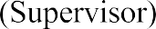

4th of September 2026

DECLARATION
We declare that this work is original, and the submitted document for the evaluation does not incorporate without acknowledgement any material previously submitted for a degree or diploma in any other University or institute of higher education to the best of our knowledge and belief. The document does not contain any material previously published or written by another person except where the acknowledgement is made in the text.

(Ms.) Hewaarachchi N.K. | EG/2021/4554
(Ms.) Lakmini S.M. | EG/2021/4639
Perera W.S.R.K. | EG/2021/4717

​The above candidates have carried out the project/research in ME 7604 Capstone Projects for the degree of Mechanical and Manufacturing Engineering under my supervision.
Name of Supervisor: Dr. A.W.B.I. Annasiwaththa

Signature: ………………………
Date: 04.09.2026

Name of the Co-supervisor(s): Ms. Anusara Wijerathna

ACKNOWLEGEMENT
Most importantly, our sincere gratitude goes to Dr. A.W.B.I. Annasiwaththa, Department of Mechanical and Manufacturing Engineering, Faculty of Engineering, University of Ruhuna for the immense support and guidance given to us from the beginning of the project. We truly value their commitment and support towards this project. Finally, our heartiest thank goes to all the individuals who have given the kind guidance and encouragement to make this project successful.

(Ms.) Hewaarachchi N.K. (EG/2021/4554)
(Ms.) Lakmini S.M. (EG/2021/4639)
Perera W.S.R.K. (EG/2021/4717)

Undergraduate,
Department of Mechanical and Manufacturing Engineering, Faculty of Engineering,
University of Ruhuna.

ABSTARCT

This project proposes the design and development of a three-engine hybrid electric Vertical Take-Off and Landing (eVTOL) Unmanned Aerial Vehicle (UAV) capable of vertical take- off, controlled transition, and efficient fixed-wing forward flight using all three propulsion units. The configuration integrates independently controlled thrust-vectoring mechanisms through a rotor tilting system, enabling smooth transition between hover and cruise conditions. A fixed wing airframe is adopted to enhance aerodynamic efficiency, structural integration, and endurance performance. Key performance indicators such as thrust-to-weight ratio, lift-to-drag ratio, transition stability, and energy consumption profiles will guide the design optimization process. Comparative analysis will be conducted against conventional tri-copter configurations to assess performance improvements. An adaptive flight control strategy has been implemented to maintain smooth transition from VTOL to Fixed wing flight. The overall system behaviour was validated through high-fidelity simulations followed by controlled experimental testing under nominal, transition, and fault-induced flight scenarios. The proposed architecture aims to demonstrate an efficient and scalable hybrid eVTOL UAV platform with potential applicability to broader real-world aerial mobility and autonomous aerial system operations.

KEYWORDS
eVTOL UAV, Hybrid Electric Propulsion, Thrust Vector Control, Rotor Tilting Mechanism, Fixed Wing Body, Transition Flight Dynamics, Adaptive Flight Control, Aerodynamic Optimization, Energy Efficiency, Distributed Propulsion System, Multi-Mode Flight Stability

Table of Contents
DECLARATION ii
ACKNOWLEGEMENT iii
List of Figures ix
List of Tables xii
Chapter 1: Introduction 1
1.1 Background Of The Problem 1
1.2 Problem Statement 2
1.3 Novelty of the Proposed Design 3
1.3.1 Advanced Architectural and Control Integration 3
1.3.2 Industrial Value 4
1.4 Scope of the Project 5
Chapter 2: LITERATURE REVIEW 7
2.1. eVTOL Configurations and Historical Development 7
2.1.1 Evolution of Tilt-Rotor Technology 7
2.1.2 Configuration Analysis Frameworks 8
2.1.3 Tri-Rotor Configuration Advantages 9
2.2 Aerodynamic Interactions in Multi-Rotor Systems 9
2.2.1 Rotor-Airframe Interference Effects 9
2.2.2 Blade Flapping Dynamics 10
2.2.3 Multi-Rotor Interference 10
2.3 Propulsion Systems and Thrust Vectoring 11
2.3.1 Tilt Mechanism Design 11
2.3.2 Power System Optimization 11
2.3.3 Thrust Vectoring Control 12
2.4 Flight Dynamics and Mathematical Modeling 12
2.4.1 Six-DOF Rigid Body Formulation 12
2.4.2 Over-Actuated System Dynamics 13
2.4.3 Transition Dynamics 13
2.5 Structural Design and Integration 14
2.5.1 T-Tail Integration Challenges 14
2.5.2 Material Selection 14
2.5.3 Weight Optimization 15
2.6 Safety, Certification, And Operational Considerations 15
2.6.1 Operational Considerations 15
2.7 Review of Similar Faculty Research 15
2.7.1 Hybrid VTOL with Model Reference Adaptive Control (MRAC) 15
Chapter 3: AIM AND OBJECTIVES 17
3.1 Aim 17
3.2 Objectives 17
3.3 Expected Outcomes 17
3.3.1. Technical Outcomes 17
3.4 Research and Publication 18
3.5 Long-Term Outcomes 18
Chapter 4: METHODOLOGY 19
4.1 To Develop the Multirotor Platform and to Tune Its Stabilization Using Ardupilot. 19
4.2 To Design and fabricate a Prototype Wing and Airframe. 19
4.3 To Test and Establish the Limits of Stability of the Aircraft During Vertical Take-Off and Landing. 20
4.4 To Test and Establish the Limits of Stability of the Aircraft During the Transition. 21
4.5 To Perform a Complete Flight, Including Vertical Take-Off, Transition, Fixed-Wing Flight, Reverse Transition, And Vertical Landing. 21
Chapter 5: Resource requirements and Budget 22
5.1 Resource Requirements 22
5.1.1 Hardware & Components 22
5.1.2 Mechanical & Structural 22
5.1.3 Software & Simulation 22
5.1.4 Fabrication & Testing 22
5.2 Budget 23
Chapter 6: CONCEPTUAL DESIGNS 24
6.1 Objective Tree 24
6.2 Functions-means diagram 25
6.3 Morphological analysis 26
6.4 Considered Designs 27
6.4.1 Design 1 27
6.4.2 Design 2 28
6.4.3 Design 3 28
6.5 Weighted Matrix 29
Chapter 7: Design 31
7.1 Solid Body 31
7.2 Rear Propeller Mount 32
7.3 Design Specification 32
Chapter 8: ANALYSIS 33
8.1 Solidworks Analysis 33
8.1.1 Aerodynamic flow analysis of the airframe (cruise mode) 33
8.1.2 Pressure distribution analysis of the airframe (cruise mode) 34
8.1.3 Propeller flow simulation – cruising (horizontal-thrust) configuration 36
8.1.4 Propeller flow simulation – hovering (vertical-thrust) configuration 36
8.2 State Space Modeling 37
8.2.1 Model Overview and Mathematical Formulation 37
8.2.2 Physical and Aerodynamic Parameters 38
8.2.3 State Vector and Sub-Matrix Partitioning 40
8.3 Vertical Lifting Phase (Hover Mode) 41
8.4 Forward Cruising Phase 45
8.4.1 Decoupled Longitudinal and Lateral-Directional Dynamics 46
Chapter 9: CALCULATIONS 50
Chapter 10: FABRICATION PROCESS 53
10.1 3D printing process 53
10.2 Materials Used in Fabrication 54
10.3 Structural Reinforcement 55
10.4 Electronic Components 56
10.4.1 Battery 56
10.4.2 Flight Controller 56
10.4.3 Electronic speed controller 58
10.4.4 GPS module 58
10.4.5 Receiver 59
10.5 Wiring diagram 60
Chapter 11: ArduPilot Configuration, Integration, and Tuning 62
11.1 Flight Controller and Firmware Overview 62
11.1.1 ArduPilot 62
11.2 AIRFRAME CONFIGURATION 63
11.3 Esc and Motor Configuration 65
11.4 RC Link and Telemetry 65
11.5 Control-Loop Tuning Methodology 67
11.5.1 PID Control Theory Fundamentals 67
11.5.2 Tuning Order 69
Chapter 12: FLIGHT TEST 72
12.1 Ground Test-Leveling Check 72
12.2 Vtol Flight Test 73
12.2.1 Overview 73
12.2.2 VTOL Test 1 73
12.2.3 VTOL Test 2 76
12.3 Horizontal Flight Test 79
12.3.1 Overview 79
12.3.2 Horizontal Flight Test 1 80
12.3.3 Horizontal Flight Test 2 83
Chapter 13: TIME PLAN 84
Chapter 14: GROUP MEMBERS CONTRIBUTION 85
REFERENCES 1
Chapter 15: Literature Review 5
Appendices 7
Appendix A Title 7

List of Figures
Figure 2.1: NASA Tiltrotor and Multi-Tiltrotor [6] 8
Figure 2.2: Falcon V2 [21] 9
Figure 2.3: Rotor-Wing Interaction Flow Field for Tilt-Rotor eVTOL Aircraft [9] 10
Figure 2.4: A basic electric propulsion system consists of a set of batteries that serve as the energy source, supplying electrical current to an electric motor that drives a propeller [17] 12
Figure 2.5: Attitude of aircraft the Newton-Euler equations of motion [16] 13
Figure 2.6:Composite structure [26] 14
Figure 2.8: The Model of the UAV 16
Figure 6.1: Objective Tree 24
Figure 6.2: Functions-means diagram 25
Figure 6.3: The Sketch of Design 1 27
Figure 6.4: The Sketch of Design 2 28
Figure 6.5: The Sketch of Design 3 28
Figure 7.1: Solid Body at Lifting Process 31
Figure 7.2: Solid Body at Cruising Process 31
Figure 7.3: Rear Propeller Mount 32
Figure 8.1: Velocity flow trajectories around the airframe in cruise mode 33
Figure 8.2: Surface velocity contour on the airframe (cruise mode) 34
Figure 8.3: Pressure distribution over the airframe, top view (cruise mode) 35
Figure 8.4: Pressure cut-plot showing the stagnation region near the nose, side view (cruise mode) 35
Figure 8.5: Simulation with propellers in cruising mode 36
Figure 8.6: Simulation with propellers in hovering mode 37
Figure 8.7: : MATLAB/Simulink Block Diagram - Vertical Lifting State Space Model 42
Figure 8.8: Body-Frame Velocities (u, v, w) vs. Time 43
Figure 8.9: Earth-Frame Position (Xe, Ye, Ze) vs. Time 43
Figure 8.10: Euler Angles (φ, θ, ψ) vs. Time 44
Figure 8.11: Angular Rates (p, q, r) vs. Time 44
Figure 8.12: MATLAB/Simulink Block Diagram – Cruise State-Space Model 46
Figure 8.13: Body-Frame Velocities (u, v, w) vs. Time 47
Figure 8.14: Earth-Frame Position (xe, ye, ze) vs. Time 47
Figure 8.15: Euler Angles (φ, θ, ψ) vs. Time 48
Figure 8.16: Angular Rates (p, q, r) vs. Time 48
Figure 10.1: K1 MAX 3D Printer 53
Figure 10.2: All Parts in UAV 54
Figure 10.3: Reinforcement 55
Figure 10.4: Battery 56
Figure 10.5: Specifications of the MATEKSYS H743-WING V3 56
Figure 10.6: Power distribution board 57
Figure 10.7: Soldered board 57
Figure 10.8: Wiring diagram of the flight controller board 57
Figure 10.9: The 4-in-1 ESC 58
Figure 10.10: The GNSS/GPS module 59
Figure 10.11: The RC receiver 60
Figure 10.12: Wiring Diagram 61
Figure 11.1: VECTOR V1 tricopter tiltrotor layout: motor placement (top view) and tilt range with mast offset (side view) 63
Figure 11.2: Generic PID feedback control loop with an added feed-forward (FF) path 67
Figure 11.3: Simplified ArduPlane VTOL yaw rate-controller cascade, from commanded yaw rate through the notch filter and FF/P/D gain stages to the tilt mixer and airframe, with gyro feedback. 69
Figure 11.4: Conceptual illustration of the yaw response delay diagnosis and its resolution. Curve shapes are illustrative only, intended to convey the diagnostic method not measured flight-log data. 70
Figure 12.1: Ground leveling check - VTOL configuration, propellers vertical. 72
Figure 12.2: VTOL take-off/hover - all three propellers directed for upward thrust. 73
Figure 12.3: VTOL Test 1 - Desired Yaw (red) vs. actual Yaw (green). 74
Figure 12.4: VTOL Test 1 - Desired Roll (red) vs. actual Roll (green). 75
Figure 12.5: VTOL Test 1 - Desired Pitch (red) vs. actual Pitch (green). 75
Figure 12.6: VTOL Test 2 - recorded ground track over the test field. 76
Figure 12.7: VTOL Test 2 - Desired Roll vs. actual Roll, after tuning. 77
Figure 12.8: VTOL Test 2 - Desired Pitch vs. actual Pitch, after tuning. 77
Figure 12.9: VTOL Test 2 - Desired Yaw vs. actual Yaw, after tuning. 78
Figure 12.10: Horizontal flight - aircraft in cruise after transition. 79
Figure 12.11: Horizontal Flight Test 1 - recorded ground track. 80
Figure 12.12: Horizontal Flight Test 1 - Desired Roll vs. actual Roll. 80
Figure 12.13: Horizontal Flight Test 1 - Desired Yaw vs. actual Yaw. 81
Figure 12.14: Horizontal Flight Test 1 - Desired Pitch vs. actual Pitch. 81

List of Tables
Table 5-1: Budget 23
Table 6-1: Morphological Chart 26
Table 6-2: Weighted Matrix 29
Table 9-1: Constant and Fixed Envelop Parameters 50
Table 11-1: Airframe and Tilt Configuration Parameters 64
Table 11-2: MOTOR AND ESC SPECIFICATIONS 65
Table 11-3: RC LINK AND TELEMETRY PARAMETERS 66
Table 11-4: QUALITATIVE EFFECT OF INCREASING EACH GAIN TERM 68
Table 13-1: Time Plan 84
Table 13-2: Descriptive Time Plan 84
Table 14-1: Group Members Contribution 85

LIST OF SYMBOLS
6-DOF Six-Degrees-of-Freedom
CFRP Carbon Fiber Reinforced Polymer
DEP Distributed Electric Propulsion
DOF Degree of Freedom
eVTOL Electric Vertical Take-Off and Landing
FAA Federal Aviation Administration
FO-MRAC Fractional-Order Model Reference Adaptive Control
GL-10 Greased Lightning 10 (NASA experimental tilt-rotor UAV)
INDI Incremental Nonlinear Dynamic Inversion
MPC Model Predictive Control
MRAC Model Reference Adaptive Control
NASA National Aeronautics and Space Administration
NDARC NASA Design and Analysis of Rotorcraft
NPUs Neural Processing Units
UAV Unmanned Aerial Vehicle
Wh/km Watt-hour per kilometer
EASA European Union Aviation Safety Agen

Introduction

Background Of The Problem
Because of their numerous industrial, defense, and civil uses, unmanned aerial vehicles (UAV) have emerged as a crucial technology in modern aerospace engineering. Search and rescue operations, infrastructure inspection, environmental monitoring, surveillance, reconnaissance, and disaster response all make extensive use of these systems. UAVs are very useful for both autonomous and semi-autonomous missions because they can carry out intricate and dangerous tasks without a human pilot on board [1].
In UAV development, the ability to take off and land vertically (VTOL) has become a game- changer. A VTOL aircraft can move into forward flight like a fixed-wing aero plane and take off, hover, and land vertically like a helicopter [2] [3]. This dual capability allows for operation in confined or infrastructure-limited environments, including ship decks, urban areas, and remote locations, and does away with the need for runways [4]. Because of their adaptability, VTOL platforms are especially appealing for mission-critical and long-range applications [6] [7].
Nonetheless, both vertical lift and a good forward cruise in one platform are difficult to accomplish without a close consideration of aerodynamics and propulsion [8] [9] [10]. The solution to this is hybrid VTOL designs which shift the prop-intensive hover to aerodynamically efficient cruise flight wherein the wings generate the lift and the propulsion power demand is greatly reduced [7]. Here, the aerodynamic efficiency of a Fixed Wing Body (FWB) design is superior to the aerodynamic efficiency of traditional fuselage-wing designs because it is less draggy and with a higher lift-to-drag (L/D) ratio. This has a direct effect of increasing endurance and extending flight range [8] [11].
Propulsion architecture is a very important aspect of the performance of VTOL UAV [12] .A three-engine (tri-rotor) design offers a lightweight and economical alternative to the traditional quadrotor designs[12] [13]. The total weight and power consumption of the system can be minimized by cutting down the number of motors [10] [11]. However, tri- rotor systems present more complex dynamic behavior because the thrust is not symmetrically distributed and the system has nonlinear forces like gyroscopic force and Coriolis force [13]. These features demand sophisticated control schemes so that there is stable flight under all operating conditions [1] [13].
Thrust vectoring technology can be incorporated into the propulsion system to increase maneuverability and control power [14] [15]. Thrust vectoring allows the engine thrust to be diverted by means of tilting [14]. The UAV can produce pure lateral and forward forces without the complete dependence on body inclination by independently tilting the three engines. This technique is called Direct Thrust Vectoring Control (DTVC) and enhances flexibility of flight and provides more control over the six degrees of freedom [14]. When the body is of high aspect ratio like with blended wing bodies, it is particularly beneficial to have a stable body orientation during maneuvering and landing [8] [14].
Besides mechanical and aerodynamic innovations, the innovative UAV systems are becoming increasingly adaptive in terms of controlling methods [1]. Adaptive control strategies change control parameters dynamically to adapt to changes in aerodynamic behavior, actuator performance, and environmental disturbances. The autopilot can react smartly to the evolving flight dynamics with techniques like Retrospective Cost Adaptive Control (RCAC) and neural-network-enhanced control systems [1] [16]. This capability increases stability in between hover and cruise phases and increases flight robustness [1] [15].
The combination of VTOL, fixed wing body aerodynamics, tri-rotor propulsion, thrust vectoring and adaptive control is a multidisciplinary approach to the next-generation UAV development. Such platforms seek to offer long-range, high maneuverability, and high operation reliability by integrating aerodynamic efficiency, propulsion innovation, and intelligent control systems to meet advanced aerospace applications [1] [7] [8] [10].

Problem Statement
- Endurance vs. Infrastructure: Conventional rotorcraft is limited by power-intensive flight requirements that restrict operational range, while fixed-wing aircraft are constrained by takeoff/landing strip requirements [5] [7] [10].
- Control Complexity and Stability: Tri-rotor systems are inherently more challenging to stabilize than quadrotors due to complex gyroscopic and Coriolis terms [12] [13].
- Coupling Issues: Conventional control schemes often couple position and attitude, meaning the UAV must tilt its body to move horizontally. In high-aspect-ratio designs (such as blended wing bodies), this "position-attitude coupling" increases the risk of wingtip strikes during landings under crosswind disturbances [8] [14] [15].
- Transition Instability: The transition phase between vertical hover and horizontal cruise is often unstable, frequently inducing a "dip" in altitude or pitch instability [1] [3] [9].

Novelty of the Proposed Design
The novelty and industrial value of the project is based on the integration of a highly efficient aerodynamic layout with a control architecture that offers unparalleled maneuvering authority and safety. By combining a tri-rotor configuration with independent three-engine thrust vectoring, a Fixed wing body, the project addresses specific technical gaps that current industrial UAVs cannot solve.

Advanced Architectural and Control Integration
- Full Actuation via Independent Vectoring: This project uses a mechanism that allows all three motor-propeller assemblies to tilt independently, in contrast to traditional tri-rotors that only tilt the tail rotor for yaw compensation [13]. This gives the UAV "full authority of torque and force vectoring," which essentially gives it six degrees of freedom [14] [15].
- Decoupled Flight Dynamics: A major novelty is the ability to achieve Direct Thrust Vectoring Control (DTVC) [14]. This allows the UAV to manipulate its forward or lateral thrust projection without pitching or rolling the body. This decoupling of position and attitude is a significant departure from standard multi-rotors, which are underactuated and must tilt to move horizontally [14] [15].
- Intelligence through Adaptive Controlling: The use of Retrospective Cost Adaptive Control (RCAC) or Neural Network-improved PID represents a shift from fixed-gain controllers to intelligent systems. These controllers "adjust themselves to the dynamics of the vehicle" in real-time, allowing the UAV to handle unconventional aerodynamics and off-nominal conditions that traditional autopilots cannot manage [1].

Industrial Value
- Enhanced Mission Endurance and Speed: The achievement of Direct Thrust Vectoring Control (DTVC) is a significant innovation [14] As a result, the UAV can control its thrust projection either forward or laterally without pitching or rolling its body. Compared to conventional multi-rotors, which are underactuated and require tilting to move horizontally, this decoupling of position and attitude represents a substantial change [15].
- Operational Versatility in Restricted Environments: The UAV has great industrial value for sensor-pointing missions, shipboard operations, and narrow-area landings because it can move laterally without tilting its body [4] [5]. For example, a camera or directional sensor can remain precisely level and aimed at a target while the UAV uses its thrust vectors alone to compensate for crosswinds [14] [15].
- Safety and Reliability (Fail-Safe Mechanisms): For valuable industrial payloads, the incorporation of adaptive control offers a strong safety net. Even in the event of malfunctioning sensors, actuators, or erratic aerodynamic changes during the transition phase, the system can continue to fly steadily [1] [15].
- Noise and Cost Reduction: Compared to conventional helicopters or high-actuator- count multicopters, the aircraft's tri-rotor configuration with distributed electric propulsion lowers maintenance costs and the noise footprint, which is crucial for urban air mobility [12] [17].
- Diverse Application Potential: The successful development of this platform has direct applications in Urban Air Mobility (UAM), search and rescue, emergency medical services, and aerial firefighting, where the combination of vertical takeoff and high-speed, long-range travel is vital [4] [5] [6] [18].

Scope of the Project
The area of interest of the project titled Development of a Long-range VTOL UAV with Three-engine thrust vectoring and Adaptive Controlling is based on the synthesis of innovative aerodynamic design, unified non-linear modeling and effective strategies of adaptive control to achieve a highly maneuverable and efficient aerial platform. Based on the provided literature, the scope in question can be outlined as follows:
- Mechanical Design and Aerodynamic Sizing.
- The design will have tri-rotor design combined with a flying-wing and this design is carefully chosen so that it improves the lift-to-drag ratio, a critical value to meet the requirement of the long-range mission.
- The actuation system will be created which will allow all three engine assemblies to be tilted independently through servomechanisms and thus provide full control of the torque and forces vectoring and give the UAV six degrees of freedom.
- Unified Mathematical Modelling.
- A six degree of freedom, non-linear dynamic, model will be obtained with the help of the Newton-Euler system.
- Tentative lift, drag and moment coefficients, C L, C D, C m shall be estimated with respect to a series of angles of attack with specific interest in interference effects between propulsive units and the wing during transitional flight.
- Adaptive Control and Thrust Vectoring Synthesis
- A control-allocation scheme will be introduced that can act to provide lateral and forward displacement by controlling the thrust vectors without involving the body in the directional attitude control.
- An intelligent controller, e.g. Retrospective Cost Adaptive Control (RCAC) or a neural-network-enhanced PID, will be synthesized, so the system can then adapt to changing vehicle dynamics and stay safe in the off-nominal case.
- Mission simulation and verification Mission performance and simulation verification
- The aero performance prediction will be done using mid-fidelity tools like RotCFD whereas MATLAB/Simulink will be validating the control law.
- The ability of the UAV to follow a complicated straight-line and circular path will be checked, and a particular maximum error will be allowed.
- The simulations will be tested for landing accuracy and attitude stability during significant disturbances produced by cross-winds compared with the traditional under-actuated schemes.
The scope of the project is limited by the following factors: The project makes use of a rigid- body airframe and does not simulate structural aeroelasticity or material fatigue. Internal motor and ESC cooling systems are not detailed modelled. Although acoustic optimization is significant to Urban Air Mobility (UAM), this is a secondary goal that can be met only to the extent that tip-speed limits are met.

LITERATURE REVIEW
This chapter reviews a comprehensive review on tri-rotor electric vertical takeoff and landing (eVTOL) aircraft configurations. It focuses on T-tail integration, distributed electric propulsion systems, control methods, and capabilities for autonomous operation. The literature review combines findings from academic research, industry reports, and certification frameworks to establish the theoretical basis for this proposal. The literature covers historical developments in tilt-rotor technology, modern advancements in electric propulsion, and new approaches to integrating artificial intelligence in urban air mobility.

eVTOL Configurations and Historical Development

Evolution of Tilt-Rotor Technology
The modern eVTOL aircraft concept is introduced by early tilt-rotor developments which was laid the groundwork for the basic aeromechanics of thrust vectoring. The Bell XV-15 (first flew in 1977) was key evidence for civilian tilt-rotor technology which was demonstrated the effectiveness of rotating nacelle designs for vertical flight. The mechanical coupling between engines and proprotors were used in the first Bell XV-15. The significant weight and complexity which was influencing developments were added by the design.
The military V-22 Osprey program advanced tilt-rotor technology further which were particularly focusing on its wing angle and the distribution of power between its engines. It became operational and showcased the potential of this configuration for long- range vertical lift missions. However, the mechanical complexity, maintenance requirements, and safety record of the V-22 highlighted the challenges in conventional turboshaft-powered tilt-rotor systems [2].
NASA's GL-10 Greased Lightning program (launched in 2015) was shifted focus toward distributed electric propulsion (DEP) for VTOL applications [20]. This experimental aircraft featured eight electric motor-driven propellers along the wing and two additional propellers on the horizontal stabilizer. The concept of hybrid electric propulsion for vertical flight was validated. The GL-10 program has showed that electric propulsion could support.

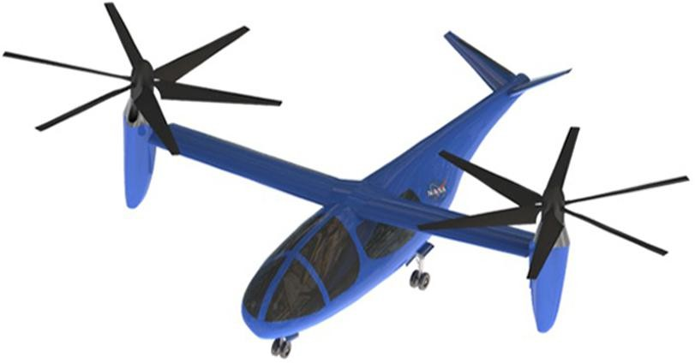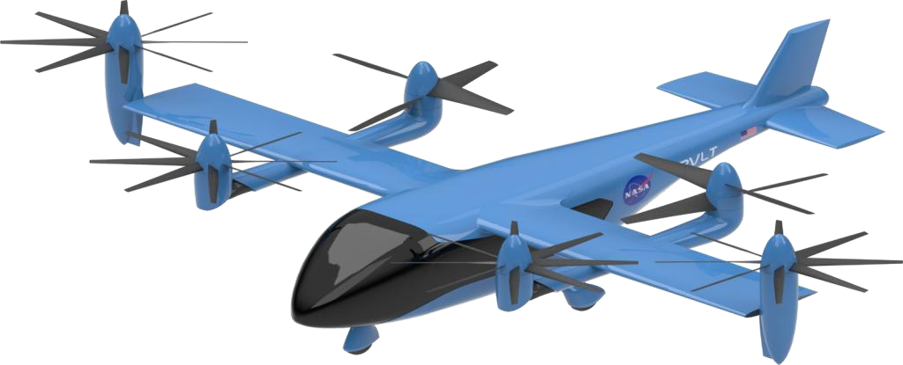
Figure 2.1: NASA Tiltrotor and Multi-Tiltrotor [6]

Configuration Analysis Frameworks
NASA's Design and Analysis of Rotorcraft (NDARC) tool offers a systematic framework to evaluate eVTOL configuration alternatives. It allows for quantitative comparisons between diverse architectural approaches [8]. Applying NDARC to urban air mobility concepts has revealed significant performance differences among configuration types. Tilt-rotor configurations consistently achieve cruise speeds that are 43-51% faster than turboshaft alternatives and 54-93% faster than electric multicopper designs [3].
This demonstrates the aerodynamic efficiency of thrust vectoring systems. One main advantage of tilt-rotor designs is the avoidance of the "dead weight" penalty found in lift- plus-cruise configurations. In those configurations, dedicated lift rotors become non- functional drag sources during cruise flight. Tilt-rotor systems keep all propulsion units active throughout the entire flight envelope. They transition from generating vertical thrust in hover to horizontal thrust in cruise. This continuous operation maximizes propulsion system use and reduces excess weight.

Tri-Rotor Configuration Advantages
Research on reduced-rotor architectures shows that tri-rotor designs can reduce the number of propulsion units by 20% - 30% compared to quad-rotor systems by providing enough control authority [13]. The asymmetric rotor placement, with two rotors mounted on the wings and one on the tail which can improves pitch control and allows for single-rotor failure tolerance. if one propulsion unit fails the Controlled emergency landings are possible to meet fault-tolerant certification requirements [21].
A practical tri-rotor design is demonstrated by the Falcon V2 platform. The wingspan is 2.1 m, a maximum takeoff weight of 7 kg, and offers a range of 300 kilometers with an energy efficiency of 1.6 Wh/km [22].
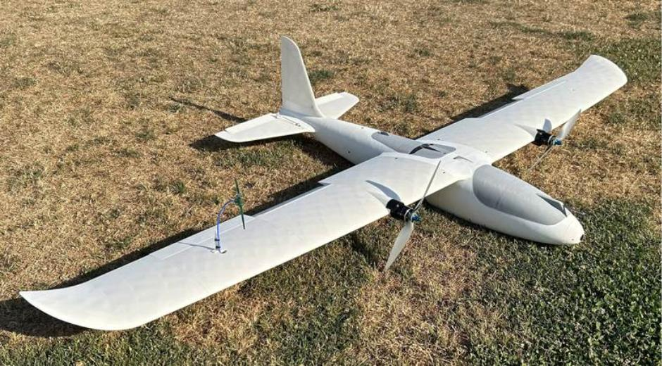
Figure 2.2: Falcon V2 [21]

Aerodynamic Interactions in Multi-Rotor Systems

Rotor-Airframe Interference Effects
The aerodynamic interaction between rotors and fixed-wing surfaces are significantly influenced eVTOL performance of the flight envelope. Technical University of Munich wind tunnel experiments with a blade of 5, 18 inch propeller at 4000 rpm discovered pressure asymmetries affecting lift distribution and generating rolling moments during transitions [9]. The airflow is hitting the wing which is increased drag and lowers efficiency When hovering (90° tilt), while mid-tilt angles (30 - 60°) cause complex wingtip vortices that make control and structure more difficult [11].

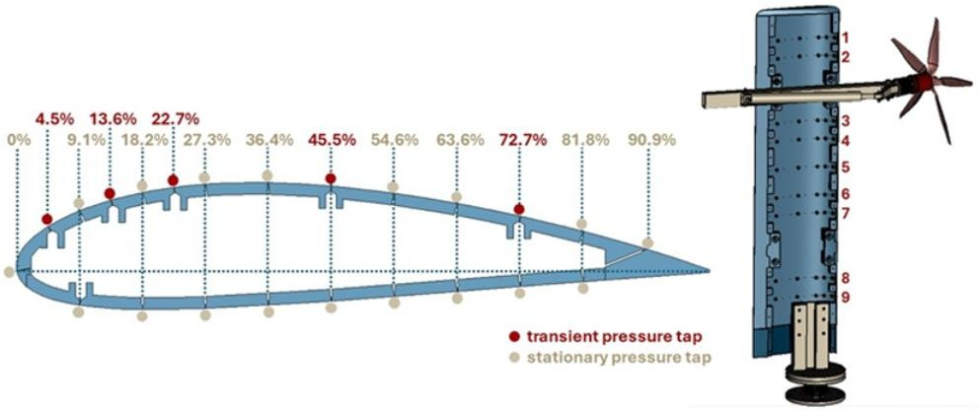
Figure 2.3: Rotor-Wing Interaction Flow Field for Tilt-Rotor eVTOL Aircraft [9]

Blade Flapping Dynamics
Blade flapping in tilt-rotors is defined by:

When is the flapping angle, the coning angle, , , are flapping coefficients, and ψ the azimuth angle [12].

Multi-Rotor Interference
Research on tandem and coaxial rotor configurations has computed the thrust degradation due to interference by providing design guidelines for multi-rotor spacing requirements. Coaxial arrangements with a 2.5R rotor spacing experience a 45% thrust reduction with a 20% efficiency loss. Lateral separation of 0.5R reduces thrust degradation to 25% with a 10% efficiency loss while the optimal 1.0R lateral spacing achieves only a 15% thrust reduction with a 6% efficiency loss.
These findings inform T-tail rotor positioning requirements and indicate that lateral separation is greater than 2.0R from wing rotor wakes which is required to minimize interference effects. Load fluctuations in closely spaced configurations are reaching the amplitudes of three times greater than those of isolated rotors which is creating structural fatigue considerations that affect design margins [23].

Propulsion Systems and Thrust Vectoring

Tilt Mechanism Design
Servo-actuated tilting mechanisms provide precise controlling over rotor orientation by allowing continuous thrust vectoring across the 0 to 90 degree range. Weight for manned eVTOL applications were suggested that each mechanism weighs around 10.5kgs. This includes the actuator, gearbox, and structural mounting hardware [24]. Development Assurance Level (DAL) A or B certification is necessary for the critical safety actuation systems. The mechanical backups, fail-safe position capability, and thorough validation testing are required.
The distributed electric propulsion architecture in modern eVTOL designs offers redundancy through independent rotor speed control and collective pitch variation. The blade design has optimized the potential of noise reduction [7]. Individual motor control allows for advanced thrust modulation strategies that are not possible with mechanically linked systems. The control methods, including model predictive control and adaptive fault accommodation are improved.

Power System Optimization
An electric VTOL aircraft requires optimized batteries and propulsion systems. Batteries provide electric power to the electric motor, allowing it to produce thrust, thereby enabling vertical take-off and cruise flight phases. Increasing battery size improves endurance but, on the other hand, affects its weight, determining its ability [10].
A strategy pursued by some recent research is to utilize hybrid configurations of batteries. In these configurations, high-power and high-energy batteries can be combined to handle the high currents required for takeoff and the high energy required to cruise efficiently. In a study on vectored thrust eVTOL optimization, it is demonstrated that a 2C + 2C hybrid configuration can increase the range by over 27% without altering the propulsor size [14].

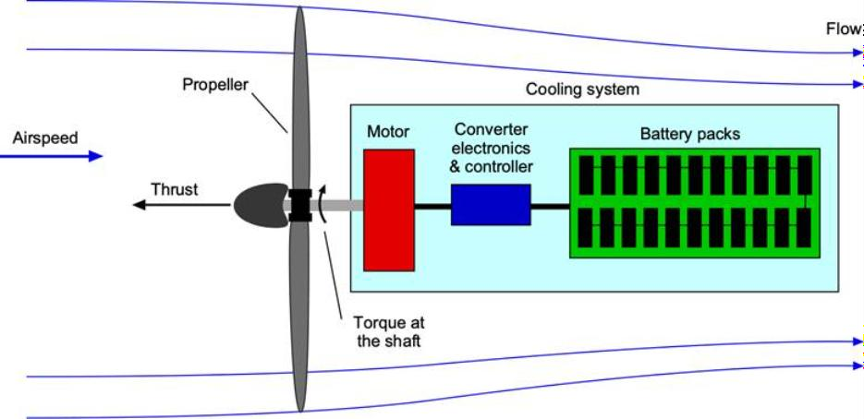
Figure 2.4: A basic electric propulsion system consists of a set of batteries that serve as the energy source, supplying electrical current to an electric motor that drives a propeller [17]

Thrust Vectoring Control
Thrust vectoring propulsors (TVPs), associated with configurations for eVTOL, are generally identified as open, ducted, and nested/coaxial.
Open TVPs offer simplicity of structure and low mass, but they result in higher acoustic emissions and poor flow efficiency. Ducted fans minimize losses at the blade tips, allowing for better flow conditions, thereby improving propulsive efficiency, but they add mass to the structure. In nesting coaxial fans, high power density is achieved, but they cause mechanical complications, interference, and losses. Research and numerical simulations about tilt-rotor aerodynamics show that the efficiency of the device during phases of transition can be greatly affected by rotor-wing interference and thrust vector orientation [9].

Flight Dynamics and Mathematical Modeling

Six-DOF Rigid Body Formulation
The six-degree-of-freedom (6-DOF) rigid body model is the basis for eVTOL flight simulation and control design. It describes aircraft motion as three translational and three rotational dynamics, which are governed by Newton–Euler equations that combine gravitational, aerodynamic, and thrust forces acting on the aircraft’s center of mass.

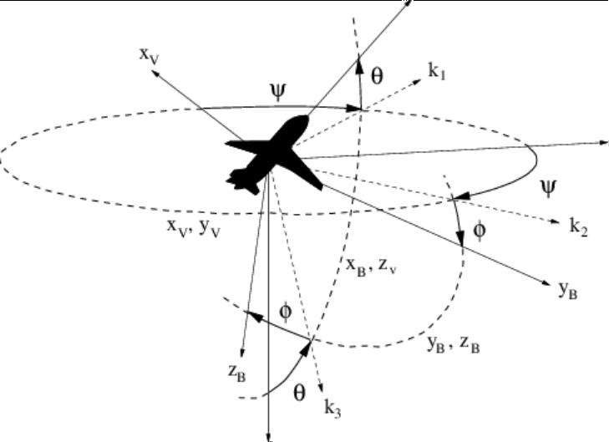
Figure 2.5: Attitude of aircraft the Newton-Euler equations of motion [16]

Over-Actuated System Dynamics
When there are actuators greater than the number of degree of freedoms, as with a tri- rotor aircraft with vectoring rotors, this type of system is known to be over-actuated. Control allocation strategies consist of controllers with specific requirements for forces, torques, optimization, and constraint of actuator efforts. Optimization methods generally follow allocation methods formulated with cost functions, which include weights based on maximum rates monitored [15].

Transition Dynamics
Transition dynamics from hover to cruise mode show many complex interactions between rotor thrust generation and aerodynamic lift generated by conventional wings or other lifting devices. Most of these studies indicate a critical transition speed corridor, which shows considerable rotor as well as wing lift generation, necessitating blended control. The research has focused on the importance of models to accurately depict unsteady aerodynamic aspects [1].

Structural Design and Integration

T-Tail Integration Challenges
T-Tail Additions of a third rotor, positioned over a T-tail, also generate concentrated loading and stress concentrations that are typically addressed near the stabilizer tip, such that gust and tilt load solution strategies do not result in failure [24].

Material Selection
These materials, namely CFRP and glass fiber composites, possess higher strength-to- weight ratio, torsional stiffness, and strength than metals. This allows for reduced airframe mass.
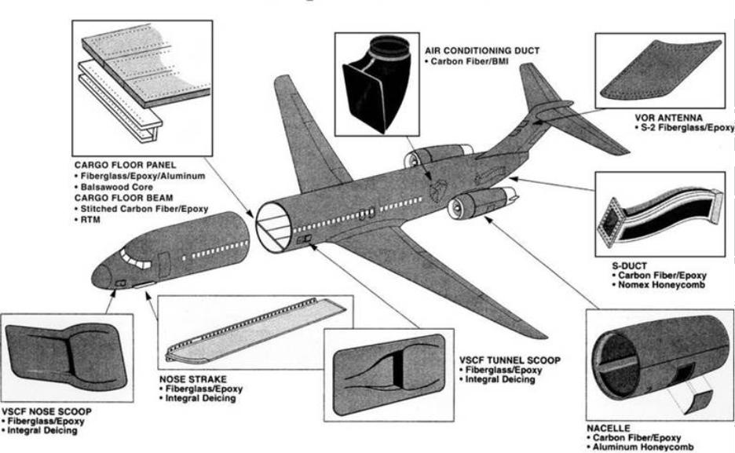
Figure 2.6:Composite structure [26]

Weight Optimization
Weight breakdowns for NDARC missions typically show ~4% electric propulsion, ~16% in flight control systems, and ~25-30% in structural components, which are considered in making design trade-offs for the payloads and system complexities [4].

Safety, Certification, And Operational Considerations

Operational Considerations
The design of the vertiport needs to take into consideration factors such as angled approaches and thrust vectoring dynamics, fast charging, noise abatement, and obstacle clearance.

Review of Similar Faculty Research

Hybrid VTOL with Model Reference Adaptive Control (MRAC)
A foundational reference for this design study is the previous research titled "Development of a VTOL Hybrid Aircraft and Implementation of a Model Reference Adaptive Control System," conducted by Group CP11 (22nd Batch) within the Department of Mechanical and Manufacturing Engineering at the University of Ruhuna. Their work explored the mechanical, aerodynamic, and control complexities inherent to hybrid vertical take-off and landing configurations, providing critical benchmarks for our current three-engine thrust vectoring architecture.
The prior study was systematically analyzed across several core engineering dimensions to inform our current design methodology:
- Hybrid VTOL Aircraft Configuration & Aerodynamics: The baseline aerodynamic body design and mechanical configuration were evaluated to identify structural vulnerabilities and flow characteristics during high-angle or multi-axis operations.
- Flight Transitions & Stability: A critical challenge in hybrid aircraft is managing the transition phase between vertical hover and forward cruise flight. The CP11 project provided substantial data regarding aerodynamic behavior and transient stability during these flight regimes.
- Adaptive Control Implementation: The previous group successfully implemented a Model Reference Adaptive Control (MRAC) system. This mathematical control scheme was evaluated to understand how parameters dynamically adjust to counteract non-linear aerodynamic forces and improve control responses.
- Testing & Validation Procedures: The practical flight testing protocols established in their study provided an empirical framework for assessing hover stability and system integration under real-world conditions.

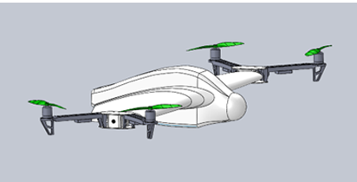
Figure 2.8: The Model of the UAV

AIM AND OBJECTIVES

Aim
To design a hybrid three-rotor eVTOL UAV that combines adaptive controlling for thrust vectoring, and energy-efficient long-range flight.

Objectives
- Design an aerodynamically validated tri rotor tilting fixed wing Unmanned Aerial Vehicle with transition of less than 3 mins with adaptive controlling of the aircraft.
- Fabricate the designed model and build a functioning product and validate the design and calculations.
- To conduct ground testing of the UAV and collect performance and operational data.
- To analyze the aerodynamic and energy performance of the developed UAV and assess the characteristics relative to conventional tri copter designs.

Expected Outcomes

Technical Outcomes
- The expected technical outcomes of this project include:
- To design and validate three-rotor eVTOL UAV system design demonstrating improved energy efficiency during forward flight compared to conventional multirotor platforms.
- A functional thrust vectoring and transition control strategy which is enabling stable operation across multiple flight modes.
- Quantitative simulation results illustrating the performance and efficiency characteristics of the proposed system.
- A modular system architecture suitable for future extension and real-world implementation.

Research and Publication
The anticipated research outcomes include:
- One primary research paper presenting the overall UAV architecture, hybrid flight concept and control methodology.
- One or more review papers addressing related topics such as eVTOL UAV configurations, hybrid propulsion systems.
- Additional focused research publications, subject to feasibility, in specialized areas including adaptive 3D flight control under actuator failure, thrust vectoring and transition dynamics in hybrid UAVs
- Complete and structured documentation with the initial project phase, with the intention of submitting research publications by the project completion timeline.
These publications are pursued voluntarily to enhance academic contribution and project rigor.

Long-Term Outcomes
Beyond the immediate scope of this project, the expected long-term outcomes include:
- Extension of the proposed design toward physical prototyping and experimental validation.
- Development of a real-world UAV platform with improved efficiency compared to conventional multirotor systems.
- Application of the AI-based edge computing framework to other UAV and autonomous systems requiring onboard intelligence and fault resilience.
- Contribution to ongoing research in efficient and autonomous eVTOL UAV technologies with potential industrial relevance.
- This project is intended to serve as a foundational research effort that bridges simulation-based design and future real-world UAV deployment.

METHODOLOGY
The methodology follows a structured engineering design process, transitioning from conceptualization and virtual validation to physical realization and testing.

To Develop the Multirotor Platform and to Tune Its Stabilization Using Ardupilot.
The following procedure will be used to develop the multirotor platform and tune its stabilization controller.
- A 3D-printed multirotor airframe will be designed and fabricated, scaled down from the Falcon V2 configuration to serve as the base platform for the aircraft.
- The platform will be fitted with an ArduPilot-based flight controller, which will handle sensor fusion (via its onboard EKF) to determine the aircraft's orientation.
- The stabilization controller will be tuned using ArduPilot's parameter tuning and autotune features, primarily in the Stabilize and FBWA flight modes.
- Tuning will be refined by analyzing the recorded data flash (.BIN) logs from test flights and adjusting parameters accordingly.
Tuning the stabilization in this way will be a critical step before further flight testing. The goal is to ensure that the aircraft can maintain stability and achieve the desired position and orientation in the absence of environmental factors such as wind.

To Design and fabricate a Prototype Wing and Airframe.
The wing and airframe will be designed and fabricated according to the following methodology.
- The required flying speed will be determined.
- An appropriate airfoil will be selected.
- Considering the airfoil's lift characteristics and the flying speed, the required wing area will be calculated.
- The wing span and chord will be determined.
- A mechanism to change the orientation of the wing relative to the fuselage will be designed; this is referred to as the angle-of-attack adjustment mechanism.
- The fuselage will be 3D-printed as a scaled-down replica of the Falcon V2 airframe, with sufficient internal room for the required electronics, tilting mechanism, sensors, and a camera module for improvements beyond the scope of this year's work.
- A model of the wing and airframe will be created in SolidWorks and analysed in Ansys Fluent.
- Based on the CFD results, modifications will be made to the design.
- Following the CFD analysis, the wing will be fabricated.
The wing design will be considered complete when the CFD analysis confirms the model performs as required.

To Test and Establish the Limits of Stability of the Aircraft During Vertical Take-Off and Landing.
The following procedure will be used to test the stability of the aircraft during take-off and landing.
- The wing will be attached to the multirotor platform, along with the angle-of-attack adjustment mechanism.
- The battery, radio receiver, and other electronics will be fitted.
- The aircraft will be controlled manually via an RC transmitter to perform a vertical take-off. This will be used to assess the stability of the aircraft during the take-off and landing stages.

To Test and Establish the Limits of Stability of the Aircraft During the Transition.
- Once the aircraft is confirmed to be stable during vertical take-off and landing, its stability during transition will be tested.
- ArduPilot's transition parameters will be configured to tilt the propeller/rotor axes from vertical to horizontal, with the aircraft's altitude held approximately constant throughout.
- A separate controller will be configured to keep the wing at the required angle of attack regardless of changes in the aircraft's orientation.
- The transition will be performed in flight, with parameters refined based on analysis of the flight logs.
This stage will be considered complete when the aircraft can transition from rotary-wing mode to fixed-wing mode without an appreciable loss of altitude.

To Perform a Complete Flight, Including Vertical Take-Off, Transition, Fixed-Wing Flight, Reverse Transition, And Vertical Landing.
- A controller will be developed for horizontal flight so that the aircraft can be flown by an RC pilot during this phase.
- A complete flight will be performed, including vertical take-off, transition, fixed-wing flight, reverse transition, and vertical landing

Resource requirement and Budget

Resource Requirement

Hardware & Components
- BLDC motors (×3): for propulsion and thrust vectoring
- Electronic Speed Controllers (ESCs): matched with motors
- Propellers (carbon-fiber or composite): optimized for efficiency
- LiPo batteries with battery management system (BMS)
- Flight controller (H743): primary flight control
- Sensors: IMU, GPS, barometer, magnetometer
- Wiring harness, connectors, power distribution board
- Safety switches and circuit protection

Mechanical & Structural
- Complete 3D CAD design of fuselage and structure (SolidWorks / Fusion 360)
- Structural materials (carbon fiber sheets/fabric, lightweight aluminum, 3D printing filament)
- 3D printing of fuselage and structural components (PLA)
- Mechanical components for thrust vectoring (servo motors, linkages)
- Landing gear system designed for emergency landing

Software & Simulation
- CAD software license/access
- Flight control firmware (PX4, ArduPilot)
- Simulation and modeling tools (e.g., Gazebo, MATLAB/Simulink)

Fabrication & Testing
- 3D printer access or outsourcing for structural parts
- CNC/laser cutting for precision components (outsourced if necessary)
- Assembly tools and fixtures
- Ground test rig for motor/thrust testing
- Safety and testing equipment for flight trials

Budget
Table 5-1: Budget
Item | Quantity | Cost (Total)
MF93ZZ flanged bearings | 6 | 2000
XRotor FPV 2812 Motors 1100KV | 3 | 19500
DIATONE MAMBA F65_128K AM32 4in1 ESC | 1 | 21600
Low weight PLA (Kg) | 1 | 10500
PETG (Kg) | 0.5 | 2600
Emax ES3054 Metal Gear Digital Servo | 5 | 23000
8x4.5 propellers | 3 | available
H7 Flight Controller | 1 | 43000
Air speed sensor | 1 | 12000
BZ 251 GPS unit | 1 | 7000
Silicon wires 10 AWG (1ft) | 1 | available
Silicon wires 16 AWG (4.5 m) | 1 | available
Servo extention cables 300mm | 2 | available
Servo extention cables 1 m | 4 | available
XT90 connector | 1 | 500
Push Rods | 10 | 1500
Carbon fiber rods (12,8,6,4 ) | 4 | 9000
Control Horns | 10 | 1200
ELRS (ExpressLRS) receiver | 1 | 6000
Special Super Glue | 2 | 1000
Li-Po Battery | 1 | 65000
Total |  | 225400

CONCEPTUAL DESIGNS

Objective Tree
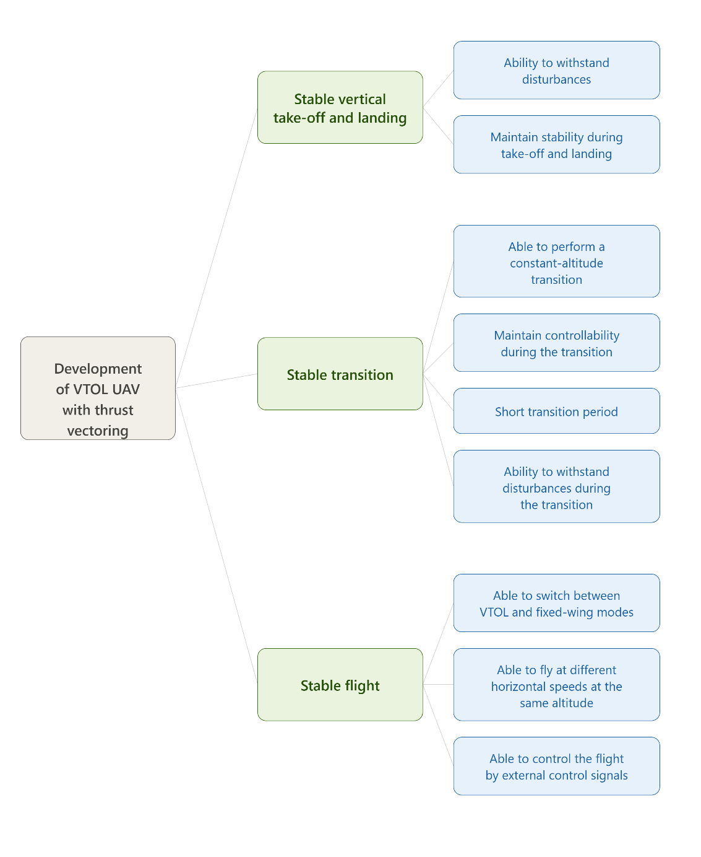
Figure 6.1: Objective Tree

Functions-means diagram
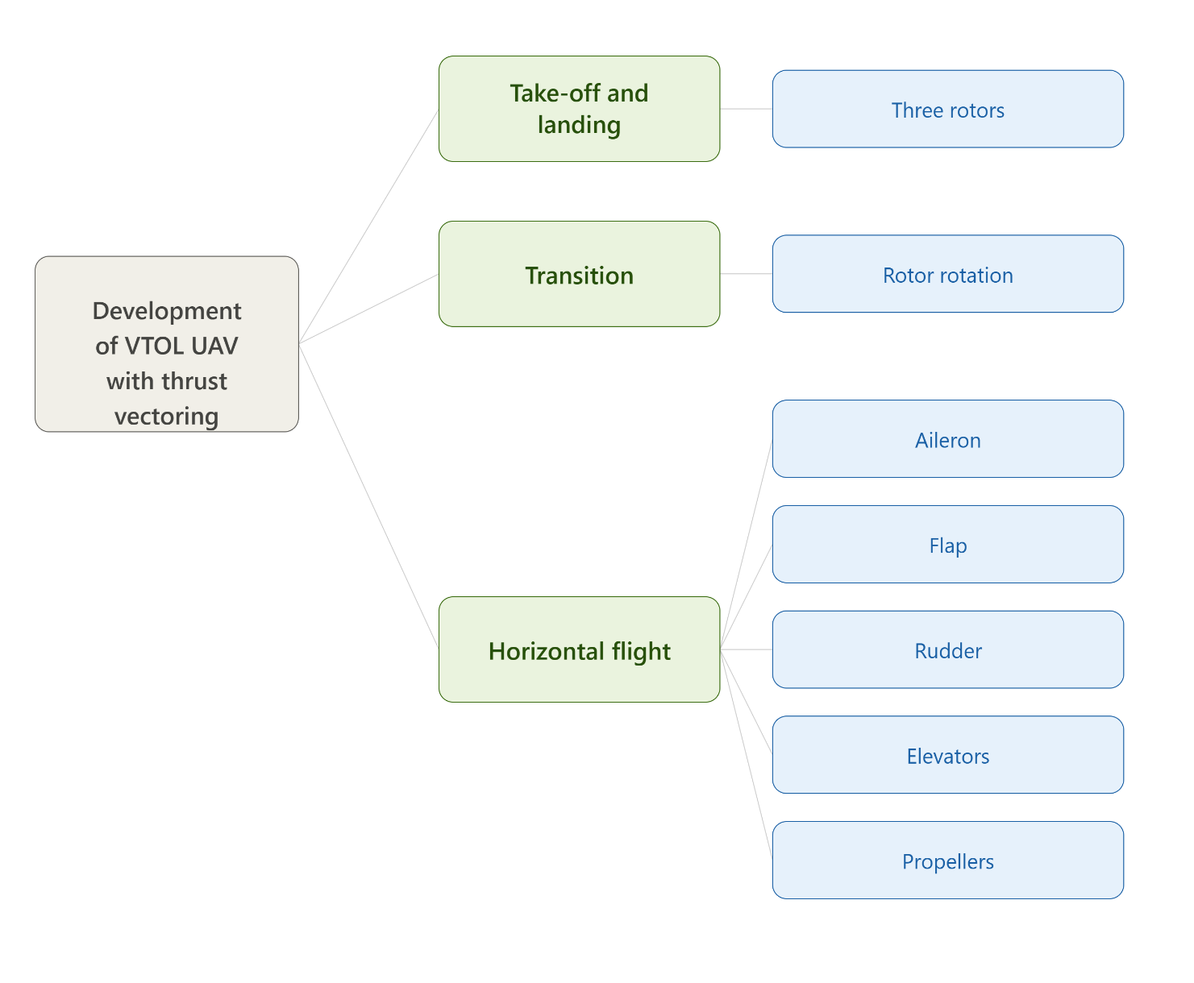
Figure 6.2: Functions-means diagram

Morphological analysis
Table 6-1: Morphological Chart
Function | Option 1 | Option 2 | Option 3
Rear Configuraton | Twin rudder | Single fin | Joined twin rudder
Rear Propeller | Body mounted | Rudder mounted | Tail boom bridge mounted
Primary Structure | Fiber glass composite | Carbon fiber plater | ePLA-LW
Reinforcement | Carbon fiber rods | Aluminum spars
Battery | LiPo | LiFe
Motor | x rotor 2812 | 4006 UAV motors | 5010 UAV motors
Speed Controller | ESc | PWM
Vectoring | Linear actuator | Tilt servos
Flight Controller | F4 | H7 | F7
Propellers | 8 x 4.5 HQ
2
1
3
1
3
2

Considered Designs

Design 1
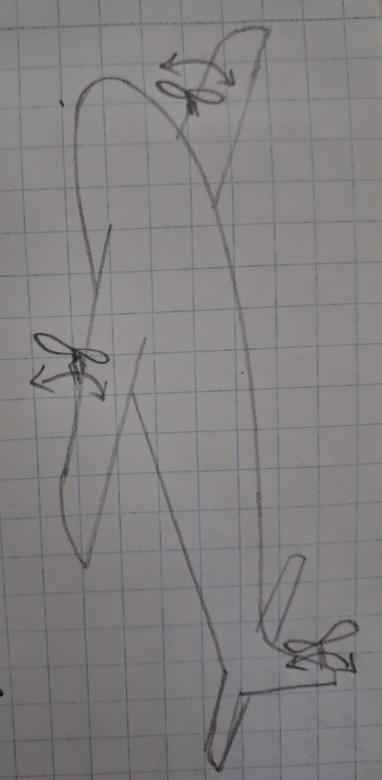
Figure 6.3: The Sketch of Design 1

This is an optimized configuration of the blended wing body design, especially optimized to facilitate the use of lightweight additive manufacturing (ePLA-LW). It also has a very streamlined, contoured central body combined with a large flying wing configuration with no external structural booms whatsoever, giving it an extremely low front cross sectional area which results in drastically reduced parasitic drag. Engineered to be a very dynamic and fully tilting tri-rotor configuration in which all three propeller assemblies are fitted with tilting mechanisms which allow for dynamic vectoring of the propeller thrust. In vertical take-off and hover all three rotors face upward producing balanced lift while during transition flight all three rotors turn forward at the same time to make the aircraft a high efficiency, forward thrusting wing configuration. The continuous, un-boomed flying wing profile makes it structurally efficient to reinforce the internal carbon fibre sections of the printed airframe with an internal carbon fibre spar, which enables the strong torsional strength to resist the complex aerodynamic forces and structural twisting moments expected during all three rotors' axis change.

Design 2
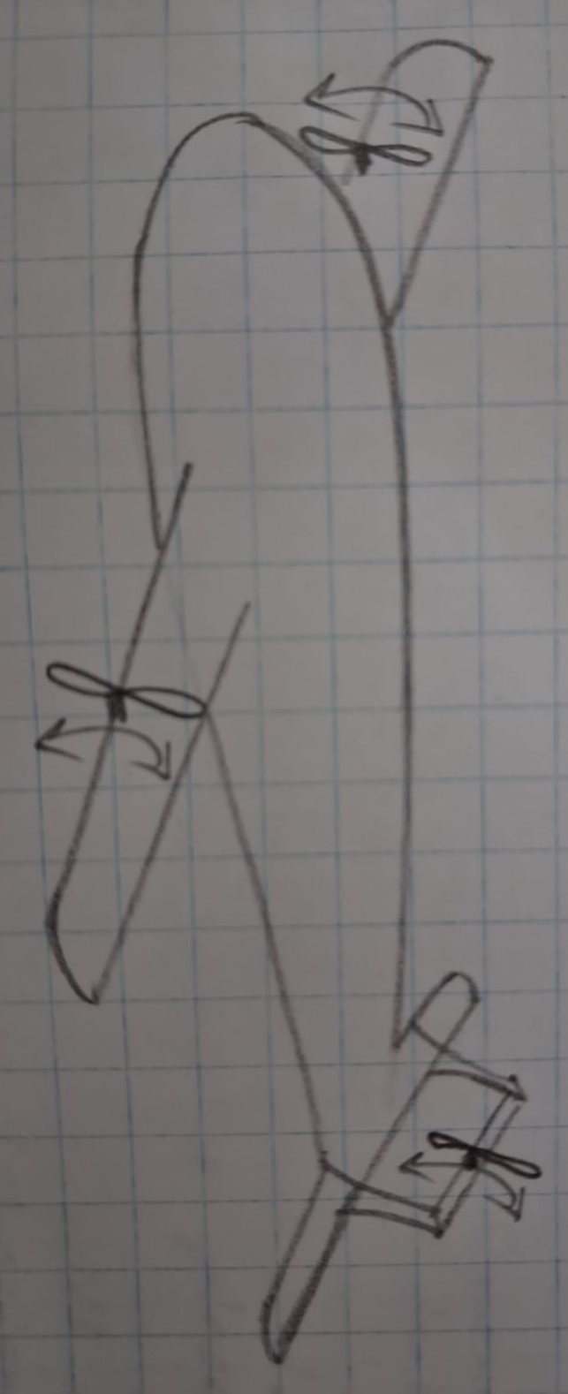
Figure 6.4: The Sketch of Design 2

The wide blended wing-body profile is an aspect of this design that blends the fuselage and wings together. This is topped with a raised central canopy pod to provide additional internal volume for the flight controller, battery and electronics. The aircraft is structurally a twin boom centered on the wing, with the booms located below the wing and extending beyond the wing leading and trailing edges. The propulsion system is a fully tilting tri-rotor system, with two front motors on the forward tips of the under-wing booms, and the third motor at the rear tail section. All three propeller assemblies are able to swivel together, moving them up and down vertically to give balanced lift for take-off and landing and then swiveling fully forward for high speed forward cruise flight.

Design 3

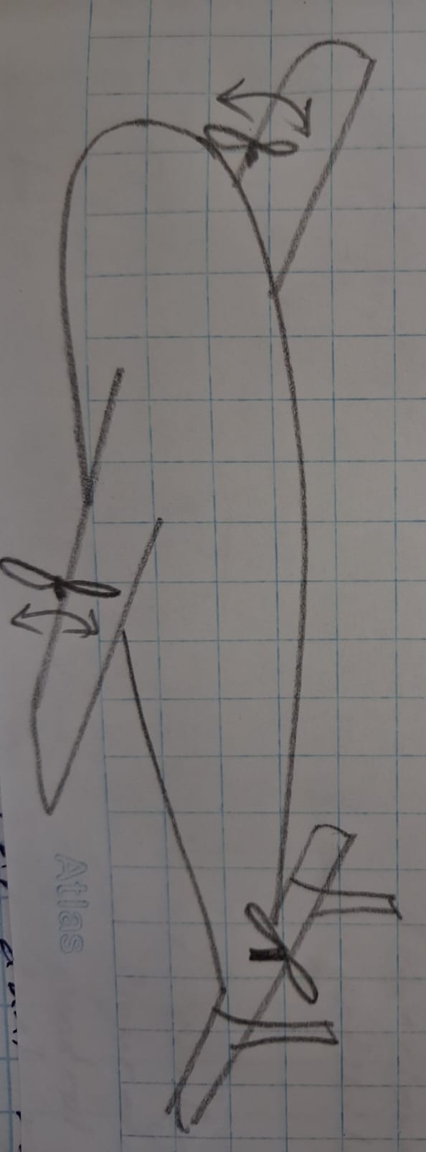
Figure 6.5: The Sketch of Design 3

This design features a wide fixed wing-body profile where the main fuselage and the wings are joined together into a single flat shape to help generate lift. On the outer sides of this main body, the aircraft uses two parallel straight bars (booms) that run from the front to the back of the wing panels. The propulsion system is set up as a fully tilting tri-rotor configuration, where all three propeller assemblies can pivot together. The two front motors are mounted directly on the forward tips of the outer bars, and the third motor is placed at the very back of the center body. This setup allows all three motors to point straight up to provide lift for vertical take-off and landing, and then tilt completely forward at the same time to push the aircraft fast during forward flight.

Weighted Matrix
Table 6-2: Weighted Matrix
Selection Criteria | Weight (%) | Option 01 (Confirmed) | Option 02 | Option 03
Weight Optimization (ePLA-LW) | 25 | 9 | 6 | 7
Processing Power (H7 vs F4/F7) | 20 | 10 | 6 | 8
Power-to-Weight Ratio (2812 Motors) | 20 | 9 | 7 | 6
Mechanical Reliability (Tilt Servos) | 15 | 8 | 5 | 7
Energy Density (LiPo Battery) | 10 | 8 | 9 | 7
Manufacturing Ease | 10 | 7 | 8 | 6
Weighted Total | 100 | 8.65 | 6.65 | 6.95

Three conceptual UAV designs were evaluated and compared against the following important engineering and operational criteria: weight optimization, processing capability, power-to-weight ratio, mechanical reliability, energy efficiency and manufacturing feasibility using a weighted matrix. The weighting percentage of each criterion was determined by how important it was to the system performance. The design concepts were then scored using each criterion and a weighted total was calculated to determine which concept was the most appropriate. The results of the evaluation show that, Option 01 has the highest weighted score of 8.65, which means that it has performed better overall than Option 02 and Option 03. Hence, Option 01 was chosen as the finalized conceptual design for detailed design, simulation, and prototype development because of its combination of a lightweight structure, a higher processing capability, efficient propulsion performance and improved mechanical reliability.

Design

Solid Body
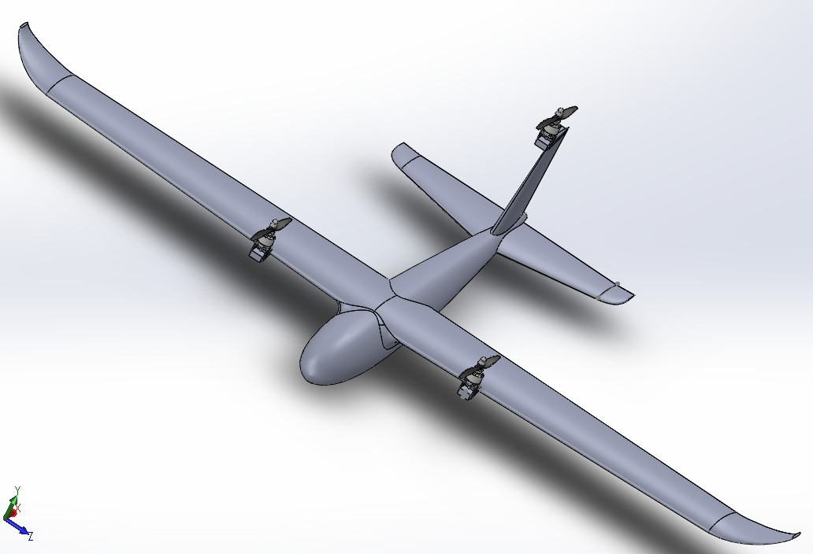
Figure 7.1: Solid Body at Lifting Process

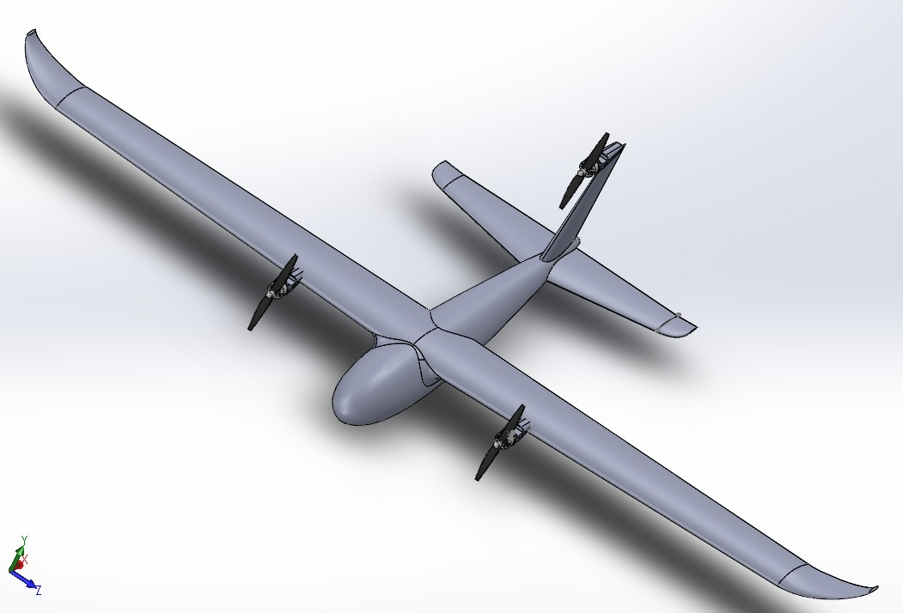
Figure 7.2: Solid Body at Cruising Process

Rear Propeller Mount

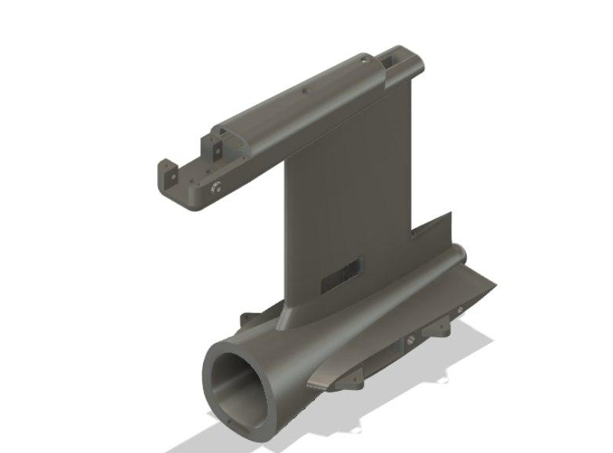
Figure 7.3: Rear Propeller Mount

Design Specification

ANALYSIS

Solidworks Analysis
This chapter presents the computational fluid dynamics (CFD) analyses carried out on the airframe and propeller assemblies using SolidWorks Flow Simulation.These simulations served as the primary means of validating the aerodynamic behaviour of the airframe and the thrust-vectoring propulsion system before fabrication and flight testing.

Aerodynamic flow analysis of the airframe (cruise mode)
A Flow Simulation study was carried out on the full CAD model of the airframe fuselage, wings and tail in its fixed-wing cruise configuration, with a uniform free-stream airflow applied along the aircraft's direction of travel.
This analysis was performed to visualise how air flows over the fuselage, wing and tail surfaces during forward flight, and to check that the flow remains smoothly attached to the airframe without significant separation, which would otherwise increase drag or reduce the effectiveness of the control surfaces.
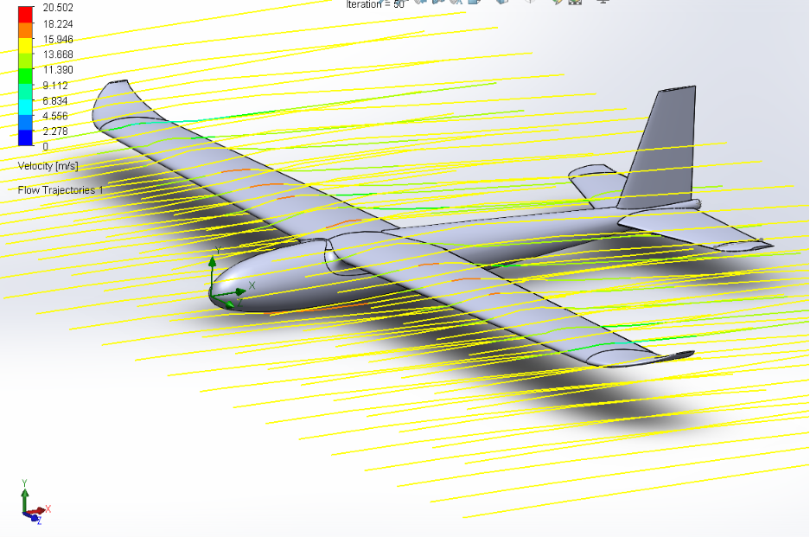
Figure 8.1: Velocity flow trajectories around the airframe in cruise mode
The flow-trajectory results show the free-stream velocity building up to approximately 20.5 m/s as it accelerates around the fuselage nose and over the upper wing surface. The streamlines remain smooth and continuous along the fuselage, wing and tail in all three viewing angles, with no visible separation or turbulent breakup at this airspeed and angle of attack
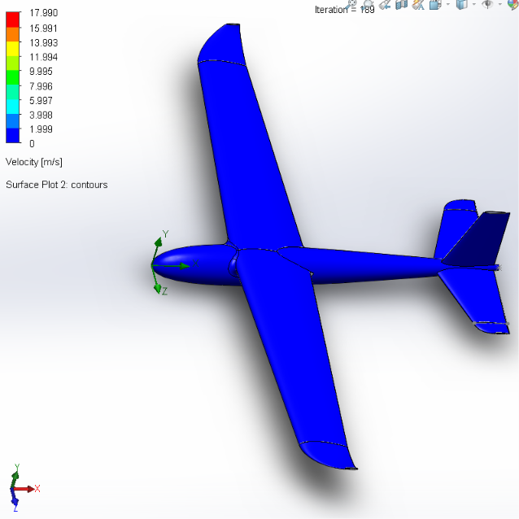
Figure 8.2: Surface velocity contour on the airframe (cruise mode)

The surface velocity contour shows a near-zero velocity directly at the airframe surface across the fuselage, wings and tail. This is the expected no-slip boundary-layer behaviour and confirms that the simulation is correctly resolving the flow immediately adjacent to the model, rather than just the free-stream region further away.

Pressure distribution analysis of the airframe (cruise mode)
Using the same flow simulation study, pressure surface and cut-plot contours were generated over the airframe and around the fuselage cross-section.
This analysis was performed to identify the pressure distribution generated by the airflow over the wing and fuselage, which relates directly to the lift produced by the wing, and to locate the regions of highest pressure (stagnation) on the airframe.
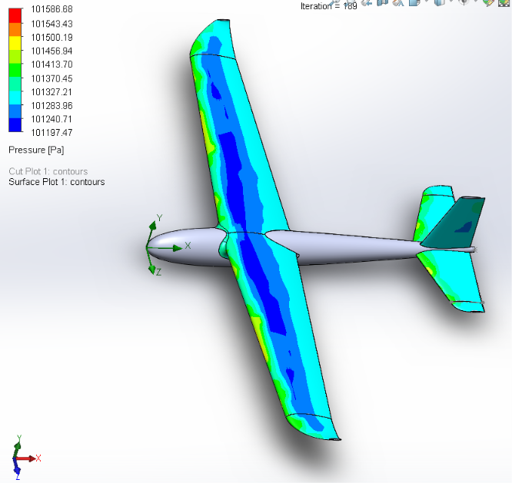
Figure 8.3: Pressure distribution over the airframe, top view (cruise mode)

A band of lower pressure (approximately 101,240–101,330 Pa) runs along the upper wing surface, consistent with the low-pressure region that generates lift, while pressure increases toward the wingtips and tail (approximately 101,410–101,590 Pa).

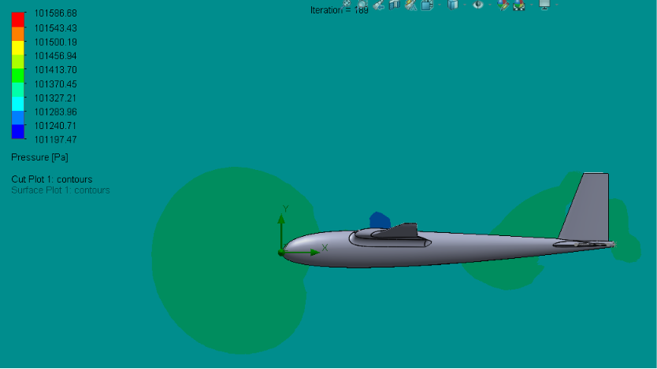
Figure 8.4: Pressure cut-plot showing the stagnation region near the nose, side view (cruise mode)

A clear stagnation region of high pressure (approximately 101,590 Pa) appears at the nose, where the airflow first meets the fuselage, along with a smaller pressure disturbance near the canopy. Both are expected features of subsonic flow over a streamlined body and are consistent with the velocity results above.

Propeller flow simulation – cruising (horizontal-thrust) configuration
A separate flow simulation was run on the propeller assemblies with the rotors oriented in their forward-tilted cruise position, rotating at the design cruise RPM.
This analysis was performed to examine the airflow and pressure field generated by the propellers when tilted for forward thrust, and to check that the propeller wake behaves as expected without adverse interference with the wing.
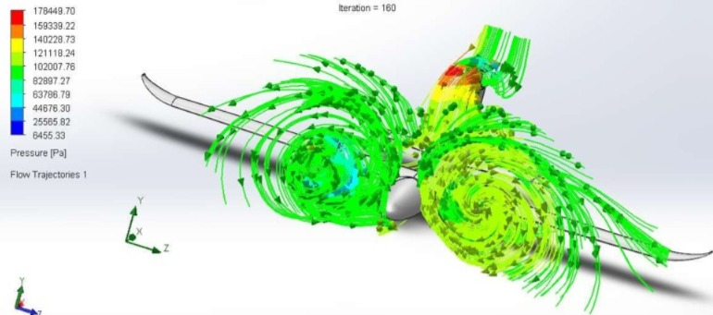
Figure 8.5: Simulation with propellers in cruising mode

The results show a clear helical wake forming behind each propeller disc, with the flow trajectories spiralling outward as expected for a rotating propeller. Pressure at the blades reaches up to approximately 178 kPa near the blade roots, consistent with the pressure rise expected across a propeller disc generating forward thrust.

Propeller flow simulation – hovering (vertical-thrust) configuration
The propeller flow simulation was repeated with the rotors tilted to their vertical, hovering position.
This analysis was performed to evaluate the downwash produced by the rotors in hover, and to check for interaction between the rotor downwash and the wing and fuselage surfaces beneath it, since this interaction can affect hover efficiency and stability.
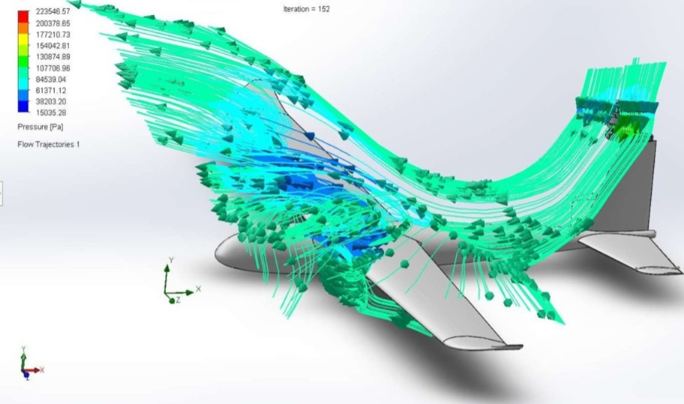
Figure 8.6: Simulation with propellers in hovering mode

The results show a strong downwash flow curling around and beneath the wing, with local pressures reaching approximately 223 kPa near the blade tips — higher than in the cruising configuration, reflecting the greater disc loading needed to generate vertical thrust for take-off and landing. The downwash is seen wrapping around the wing surface, indicating a degree of rotor–wing aerodynamic interaction during hover that may warrant further investigation

State Space Modeling

Model Overview and Mathematical Formulation
The flight dynamics of the Falcon V2 tri-rotor thrust-vectored VTOL UAV were modeled using a 12-state linear continuous-time state-space representation:
$$\dot{x}=Ax+Bu \\ y=Cx+Du$$where:
- $x∈R^{12}$ is the state vector capturing rigid-body 6-DOF kinematics and navigation states.
- $u$ is the control input vector ($u_{lift}∈R^{6}$ in hover mode, $u_{cruise}∈R^{4}$ in forward flight mode).
- $A∈R^{12×12}$ is the plant system matrix describing unforced rigid-body and aerodynamic dynamics.
- $B$ is the control input matrix mapping actuator forces and moments to state derivatives.
- $C=I_{12×12}$ is the output matrix assuming full-state observability.
- $D=0_{12×m}$ is the direct transmission matrix.

Physical and Aerodynamic Parameters
The state-space matrices were derived based on geometric dimensions, mass properties, and propulsion limits:
Parameter | Symbol | Value | Unit | Description / Reference
All-Up Mass | $$m$$ | 2.50 | $$kg$$ | Total takeoff mass
Center of Gravity Location | $$\left[{CG}_{x},{CG}_{y},{CG}_{z}\right]$$ | $$\left[0.00,0.10928,0.00\right]$$ | $$m$$ | Measured relative to airframe geometric origin
Roll Moment of Inertia | $$I_{xx}$$ | 0.03695 | $$kg⋅m^{2}$$ | Resistance to roll angular acceleration
Pitch Moment of Inertia | $$I_{yy}$$ | 0.09398 | $$kg⋅m^{2}$$ | Resistance to pitch angular acceleration
Yaw Moment of Inertia | $$I_{zz}$$ | 0.12486 | $$kg⋅m^{2}$$ | Resistance to yaw angular acceleration
Product of Inertia XY | $$I_{xy}$$ | 0.00521 | $$kg⋅m^{2}$$ | Roll–pitch inertial cross-coupling
Product of Inertia XZ | $$I_{xz}$$ | -0.00427 | $$kg⋅m^{2}$$ | Roll–yaw inertial cross-coupling
Product of Inertia YZ | $$I_{yz}$$ | -0.00120 | $$kg⋅m^{2}$$ | Pitch–yaw inertial cross-coupling
Wing Span | $$b$$ | 1.56 | $$m$$ | Main wing lateral dimension
Wing Planform Area | $$S$$ | 0.6358 | $$m^{2}$$ | Reference aerodynamic surface area
Mean Aerodynamic Chord | $$\overline{c}$$ | 0.1717 | $$m$$ | Characteristic longitudinal aerodynamic length
Left Rotor Position (from CG) | $$\left[x_{L},y_{L},z_{L}\right]$$ | $$\left[0.22499,-0.10928,0.0534\right]$$ | $$m$$ | Vectoring tilt-rotor lever arm
Right Rotor Position (from CG) | $$\left[x_{R},y_{R},z_{R}\right]$$ | $$\left[-0.22499,-0.10928,0.0534\right]$$ | $$m$$ | Vectoring tilt-rotor lever arm
Tail Rotor Position (from CG) | $$\left[x_{T},y_{T},z_{T}\right]$$ | $$\left[0.00,0.32572,0.1630\right]$$ | $$m$$ | Longitudinal balancing rotor lever arm
Maximum Static Thrust | $$T_{max}$$ | 16.35 | $$N$$ | Maximum rated thrust per motor
Tilt Angle Range | $$δ_{tilt}$$ | $$0^{∘} to {90}^{∘}$$ | $$deg$$ | $$0^{∘}=\text{Vertical Hover}, {90}^{∘}=\text{Forward Flight}$$
Nominal Airspeed | $$V_{∞}$$ | 16.0 | $$m/s$$ | Linearization cruise equilibrium point
Atmospheric Density | $$ρ$$ | 1.225 | $${kg/m}^{3}$$ | Sea-level ambient air density

State Vector and Sub-Matrix Partitioning
The 12 dynamic states are arranged into four physical sub-vectors:
$$x={\left[\begin{matrix}\underset{\text{Linear Velocities}}{\underbrace{u v w}} & \underset{\text{Angular Rates}}{\underbrace{p q r}} & \underset{\text{Euler Angles}}{\underbrace{ϕ θ ψ}} & \underset{\text{Earth Positions}}{\underbrace{X_{e} Y_{e} Z_{e}}}\end{matrix}\right]}^{T}$$
- $\left[u,v,w\right]$ ($m/s$): Axial (forward), side-slip (lateral), and normal (heave) translational velocities defined in the body-fixed coordinate frame.
- $\left[p,q,r\right]$ ($rad/s$): Body angular rates representing roll, pitch, and yaw rotation speeds.
- $\left[ϕ,θ,ψ\right]$ ($rad$): Euler angles representing roll, pitch, and yaw orientations relative to the inertial frame.
- $\left[X_{e},Y_{e},Z_{e}\right]$ ($m$): Spatial positions defined in the North-East-Down (NED) Earth-fixed frame.
The general system matrix $A∈R^{12×12}$ was partitioned into $3×3$ functional sub-matrices:
$$A=\left[\begin{matrix}A_{\text{trans}} & A_{\text{rot-cross}} & g⋅R_{\text{grav}} & 0_{3×3} \\ A_{\text{aero-mom}} & A_{\text{damp}} & 0_{3×3} & 0_{3×3} \\ 0_{3×3} & I_{3×3} & 0_{3×3} & 0_{3×3} \\ R_{\text{kin}} & 0_{3×3} & 0_{3×3} & 0_{3×3}\end{matrix}\right]$$
- $A_{trans}$ ($3×3$): Translational stability derivatives ($\frac{∂F}{∂V}$) describing forces generated by velocity perturbations.
- $A_{rot-cross}$ ($3×3$): Kinematic coupling terms between body angular rates and linear accelerations ($V×ω$).
- $g⋅R_{grav}$ ($3×3$): Gravity resolution matrix mapping gravitational components into the body frame as a function of tilt angles $\left[ϕ,θ\right]$.
- $A_{aero-mom}$ ($3×3$): Aerodynamic moment derivatives ($\frac{∂M}{∂V}$) showing moments induced by linear velocity changes.
- $A_{damp}$ ($3×3$): Rotational aerodynamic damping derivatives ($\frac{∂M}{∂ω}$) providing angular rate damping.
- $I_{3×3}$ ($3×3$): Small-angle kinematic identity mapping body rates directly to Euler angle rates ($\dot{Φ}≈ω$).
- $R_{kin}$ ($3×3$): Direction cosine rotation matrix transforming body linear velocities into Earth-frame trajectory rates.

Vertical Lifting Phase (Hover Mode)
During the vertical takeoff and hover phase, the main wings generate zero aerodynamic lift. Equilibrium and control are achieved through thrust vectoring across the three propulsion units.
Actuation and Control Matrix Formulation
The hover control vector incorporates six independent actuator channels:
$$u_{lift}={\left[\begin{matrix}dT_{1} & dT_{2} & dT_{3} & da_{1} & da_{2} & da_{3}\end{matrix}\right]}^{T}$$
$dT_{1},dT_{2},dT_{3}$: Incremental thrust changes for the front-left, front-right, and rear lifting rotors ($0≤T_{i}≤16.35 N$).
$da_{1},da_{2},da_{3}$: Angular tilt servo deflections providing horizontal force vectoring and yaw moments.
The control allocation matrix $B_{lift}∈R^{12×6}$ is partitioned as:
$$B_{lift}=\left[\begin{matrix}B_{thrust} & | & B_{tilt}\end{matrix}\right]$$
$B_{thrust}$ maps differential thrust commands to vertical heave ($\dot{w}$), roll acceleration ($\dot{p}$ via left/right differential thrust), and pitch acceleration ($\dot{q}$ via front/rear differential thrust).
$B_{tilt}$ maps servo tilt deflections to lateral/longitudinal forces and directional yaw moments ($\dot{r}$).
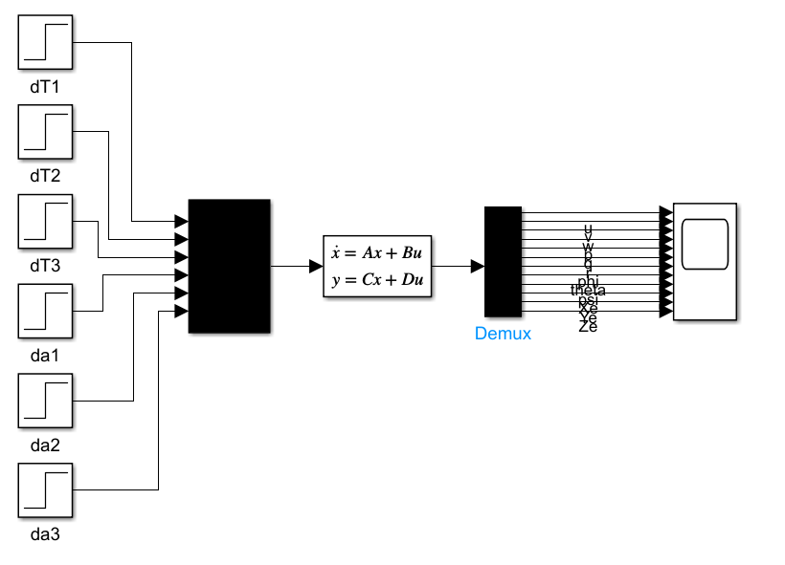
Figure 8.7: : MATLAB/Simulink Block Diagram - Vertical Lifting State Space Model

Figure 8.7 shows the open-loop test harness used to generate the hover response data. Six independent step-input blocks excite the actuator channels of the control vector u_lift = [dT1, dT2, dT3, da1, da2, da3]^{T} three differential thrust commands and three tilt-servo deflections. These are combined through a Mux block and fed into the state-space block implementing ẋ = Ax + Bu, y = Cx + Du. The 12-element output vector is separated by a Demux block into its physical components (u, v, w, p, q, r, φ, θ, ψ, Xe, Ye, Ze) and routed to a Scope for time-domain visualization. No feedback path exists in this configuration, so the resulting plots represent the raw, uncontrolled dynamic response of the airframe.
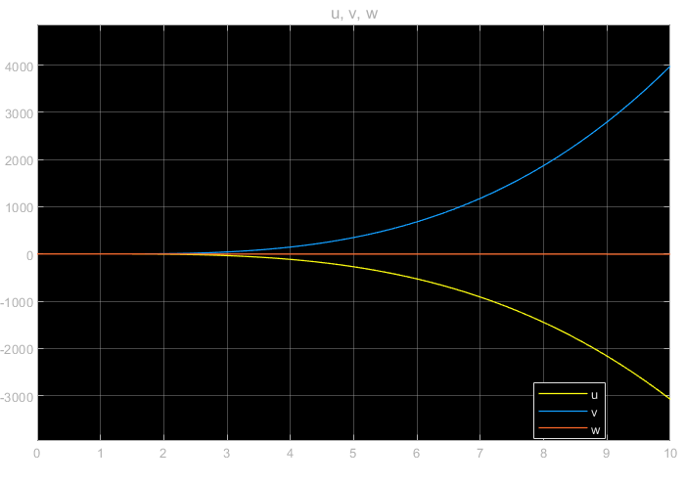
Figure 8.8: Body-Frame Velocities (u, v, w) vs. Time
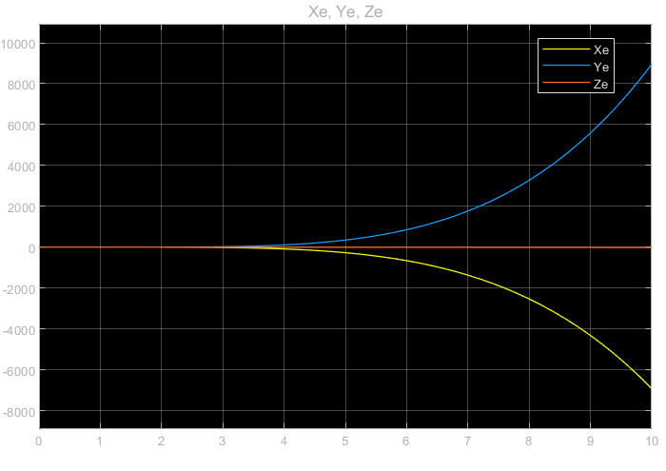
Figure 8.9: Earth-Frame Position (Xe, Ye, Ze) vs. Time
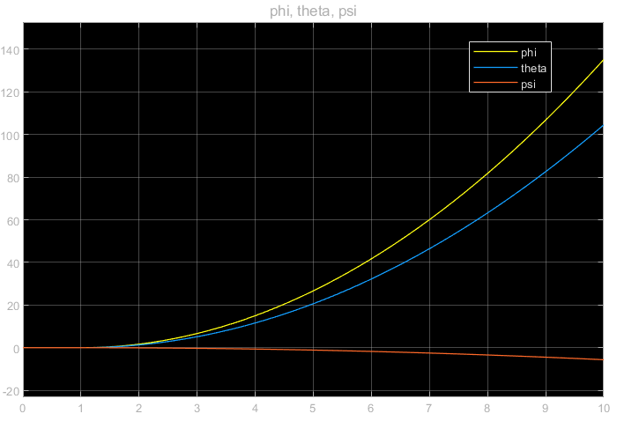
Figure 8.10: Euler Angles (φ, θ, ψ) vs. Time
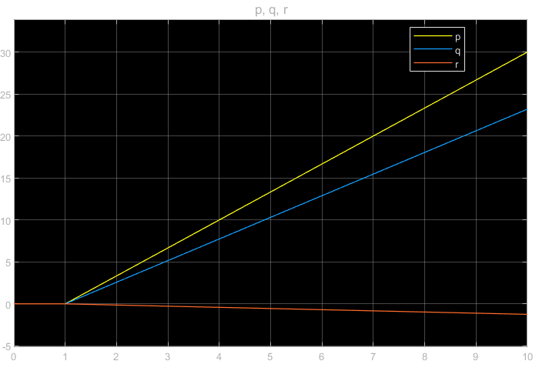
Figure 8.11: Angular Rates (p, q, r) vs. Time

According to figure 8.8 , forward velocity (u) falls to roughly −3000 while lateral velocity (v) rises to roughly +4000 by t = 10 s; heave velocity (w) remains close to zero. Magnitudes on the order of thousands of m/s confirm this is a numerical divergence typical of an unstabilized linear model, not a physically realizable flight condition. As the integral of the velocity states, position drifts to comparably extreme values Xe toward −7000 and Ye toward +9000 while Ze (vertical/down position) stays essentially flat. This confirms that the divergence originates in the attitude/rate dynamics and propagates through translational velocity into position. In Figure 8.10, Roll (φ) and pitch (θ) both increase exponentially, exceeding 100 within the 10-second simulation window, while yaw (ψ) drifts slowly negative. Because these angles have no corrective mechanism acting against them, small initial perturbations are amplified without bound the defining signature of an open-loop unstable system. Acording to Figure 8.11, Roll rate (p) and pitch rate (q) ramp up to approximately 30 rad/s and 23 rad/s respectively by t = 10 s, after a brief initial lag, while yaw rate (r) stays small and slightly negative. Since these rates are the direct time-derivatives of the Euler angles, this plot is the underlying cause of the divergence seen in Figure 8.10.

Forward Cruising Phase
In the cruising regime, the front vectoring mechanisms are fully tilted forward (${90}^{∘}$), and lift is generated by the fixed-wing planform.
Actuation and Control Allocation
The cruise control vector comprises four standard fixed-wing control channels:
$$u_{cruise}={\left[\begin{matrix}dT & da & de & dr\end{matrix}\right]}^{T}$$
$dT$: Forward propulsive thrust command for airspeed regulation.
$da$: Aileron surface deflection for aerodynamic roll control.
$de$: Elevator surface deflection for longitudinal pitch and angle-of-attack control.
$dr$: Rudder surface deflection for directional yaw trimming.
The control matrix $B_{cruise}∈R^{12×4}$ is defined as:
$$B_{cruise}=\left[\begin{matrix}B_{prop} & | & B_{aero}\end{matrix}\right]$$
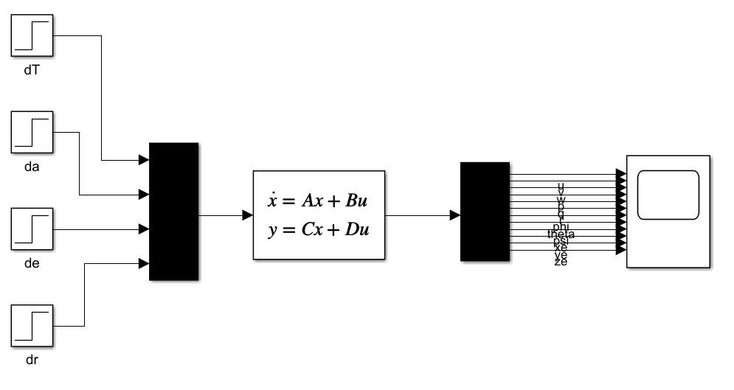
Figure 8.12: MATLAB/Simulink Block Diagram – Cruise State-Space Model

Figure 8.12 , mirrors the structure of Figure 1 but for the fixed-wing control set u_cruise = [dT, da, de, dr]T thrust, aileron, elevator, and rudder. The same state-space block and 12-state Demux/Scope arrangement are used, allowing the cruise-mode open-loop dynamics to be observed under identical step-input excitation conditions.

Decoupled Longitudinal and Lateral-Directional Dynamics
At the $16 m/s$ equilibrium cruise condition, the aircraft dynamics decouple into two independent 4-state subsystems:
Longitudinal State-Space Subsystem ($x_{lon}={\left[u,w,q,θ\right]}^{T}$)
$$\left[\begin{matrix}\dot{u} \\ \dot{w} \\ \dot{q} \\ \dot{θ}\end{matrix}\right]=\left[\begin{matrix}X_{u} & X_{w} & X_{q}-W_{0} & -gCosθ_{0} \\ Z_{u} & Z_{w} & Z_{q}+U_{0} & -gSinθ_{0} \\ M_{u} & M_{w} & M_{q} & 0 \\ 0 & 0 & 1 & 0\end{matrix}\right]\left[\begin{matrix}u \\ w \\ q \\ θ\end{matrix}\right]+\left[\begin{matrix}X_{δe} & X_{δT} \\ Z_{δe} & Z_{δT} \\ M_{δe} & M_{δT} \\ 0 & 0\end{matrix}\right]\left[\begin{matrix}de \\ dT\end{matrix}\right]$$
Lateral-Directional State-Space Subsystem ($x_{lat}={\left[v,p,r,ϕ\right]}^{T}$)
$$\left[\begin{matrix}\dot{u} \\ \dot{p} \\ \dot{r} \\ \dot{ϕ}\end{matrix}\right]=\left[\begin{matrix}Y_{v} & Y_{p} & Y_{r}-U_{0} & gCosθ_{0} \\ L_{v} & L_{p} & Z_{q}+U_{0} & 0 \\ N_{v} & N_{p} & N_{r} & 0 \\ 0 & 1 & tanθ_{0} & 0\end{matrix}\right]\left[\begin{matrix}v \\ p \\ r \\ ϕ\end{matrix}\right]+\left[\begin{matrix}Y_{δa} & Y_{δr} \\ L_{δa} & L_{δr} \\ N_{δa} & N_{δr} \\ 0 & 0\end{matrix}\right]\left[\begin{matrix}da \\ dr\end{matrix}\right]$$

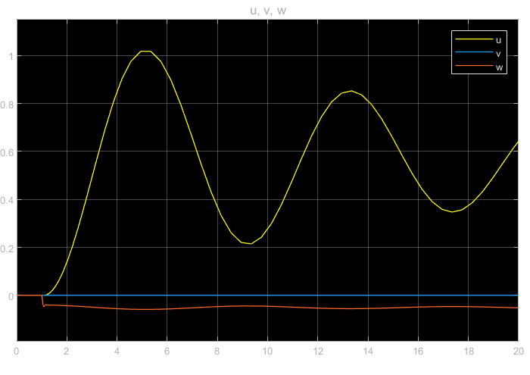
Figure 8.13: Body-Frame Velocities (u, v, w) vs. Time
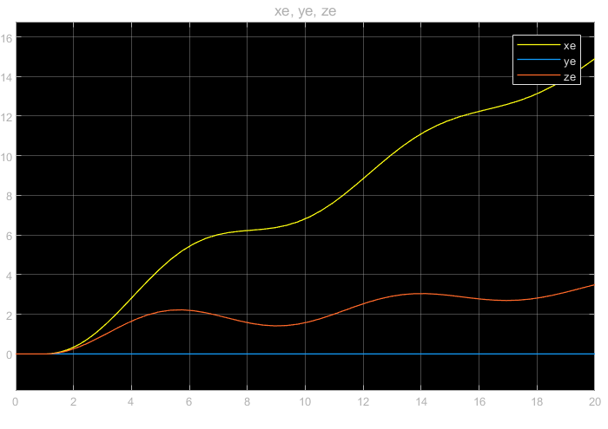
Figure 8.14: Earth-Frame Position (xe, ye, ze) vs. Time

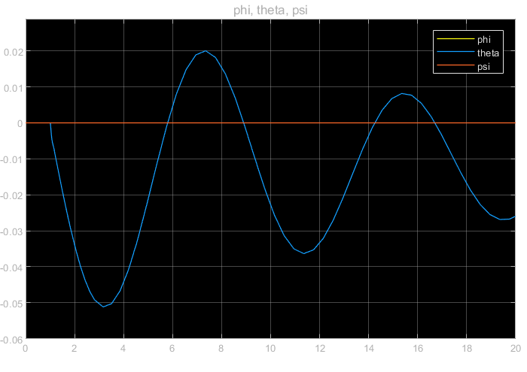
Figure 8.15: Euler Angles (φ, θ, ψ) vs. Time
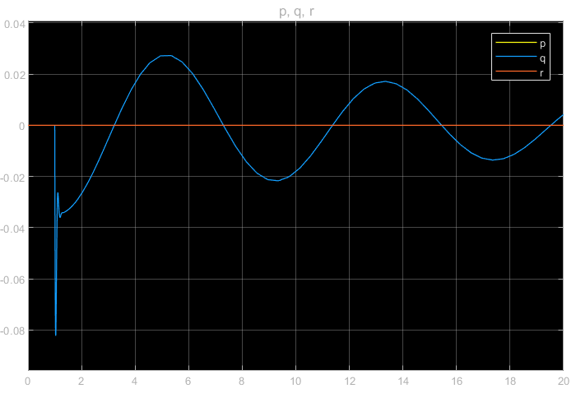
Figure 8.16: Angular Rates (p, q, r) vs. Time

According to Figure 8.13, Forward velocity perturbation (u) oscillates between approximately 0.2 and 1.0 m/s with progressively decreasing amplitude a classic slow, lightly damped long-period oscillation. Lateral velocity (v) and heave velocity (w) stay near zero, again reflecting the purely longitudinal nature of the disturbance. In Figure 8.14, Longitudinal position (xe) climbs steadily to approximately 15 m with a shallow S-shaped profile as forward speed recovers between oscillation cycles, while altitude deviation (ze) oscillates gently between roughly 0 and 3 m before leveling off. Lateral position (ye) remains at zero, consistent with no lateral-directional excitation in this test case.
In Figure 8.16, Pitch rate (q) exhibits a damped oscillation, swinging between about −0.08 and +0.03 rad/s over the 20-second window before settling toward zero. Roll rate (p) and yaw rate (r) remain essentially flat at zero, indicating that this disturbance excites only the longitudinal axis, with negligible cross-coupling into the lateral-directional states. Pitch angle (θ) follows the same damped oscillatory pattern as pitch rate in Figure 8.16 consistent with θ̇ ≈ q swinging between roughly −0.05 and +0.02 rad before slowly decaying. Roll (φ) and yaw (ψ) remain at zero throughout, confirming the longitudinal/lateral decoupling described in the model formulation.
Unlike the divergent hover mode, the vehicle states remained strictly bounded, demonstrating smooth, low-frequency oscillations. The dynamic response displays the classical aircraft phugoid mode. Continuous airflow across the main wing ($b=1.56\text{ m}$) and vertical/horizontal tail surfaces provides natural aerodynamic damping ($M_{q},L_{p},N_{r}$) and restoring moments ($M_{w},L_{v},N_{v}$). This confirms the inherent aerodynamic stability of the Falcon V2 at $16\text{ m/s}$ cruise, allowing the flight controller to prioritize guidance and navigation rather than aggressive stabilization

CALCULATIONS
Table 9-1: Constant and Fixed Envelop Parameters
Parameters | Value
Target Aircraft Mass (m) | 3.0 kg
Acceleration due to Gravity (g): | 9.81 m/s²
Cruise Air Velocity (V∞): | 15 m/s
Reference Wing Area (S_{ref}): | 0.268 m²
Air Density (ρ): | 1.112 kg/m³ (at 1000m altitude, 15°C)
Nominal Battery Voltage (V_{nominal}): | 22.2 V (6S Li-Po pack)
Battery Capacity (C_{batt}): 8000 mAh = 8.0 Ah | 8000 mAh = 8.0 Ah
Total Propulsion Efficiency (η_{total}) | 0.65

For steady, level flight, the aircraft's aerodynamic lift (L) must perfectly balance its weight (W):
$$W$$ | $$=$$ | $$m .g$$
 | $$=$$ | $$3.0 kg × 9.81 m/s²$$
 | $$=$$ | $$29.43 N$$
The standard aerodynamic lift formula is defined as:
$$L$$ |  | $$0.5 · ρ · V_∞² · S_ref · C_L$$
Setting L = W and rearranging to isolate CL:
$$C_L_cruise$$ | $$=$$ | $$(2 · W) / (ρ · V_∞² · S_ref)$$
 | $$=$$ | $$\frac{(2 × 29.43 N) }{(1.112 kg/m³ × (15 m/s)² × 0.268 m²)}$$
 | $$=$$ | $$0.877804$$
To match our target CL_cruise = 0.877804, we isolate the upper and lower boundary rows from the polars:
- Lower Bound Row: α₁ = 3.2°, C_L₁ = 0.870606, C_D₁ = 0.039346
- Upper Bound Row: α₂ = 3.3°, C_L₂ = 0.879317, C_D₂ = 0.039934
The interpolation fraction (f) is calculated as:
$$f$$ | $$=$$ | $$(C_L_cruise - C_L1) / (C_L2 - C_L1)$$
 | $$=$$ | $$\frac{(0.877804 - 0.870606) }{(0.879317 - 0.870606)}$$
 | $$=$$ | $$0.826312$$
Trim Angle of Attack (α_cruise):
$$α_cruise$$ | $$=$$ | $$α_1 + f · (α_2 - α_1)$$
 | $$=$$ | $$3.2° + 0.826312 × (3.3° - 3.2°)$$
 | $$=$$ | $$3.2826°$$
Cruise Drag Coefficient (C_{D}_cruise):
$$C_D_cruise$$ | $$=$$ | $$C_D1 + f · (C_D2 - C_D1)$$
 | $$=$$ | $$0.039346 + 0.826312 × (0.039934 - 0.039346)$$
 | $$=$$ | $$0.039832$$
Aerodynamic Drag Force (D):
$$D$$ | $$=$$ | $$(1/2) · ρ · V_∞² · S_ref · C_D_cruise$$
 | $$=$$ | $$0.5 × 1.112 kg/m³ × (15 m/s)² × 0.268 m² × 0.039832$$
 | $$=$$ | $$1.33544 N$$
Required Mechanical Power (P_mech):
$$P_mech$$ | $$=$$ | $$D × V_∞$$
 | $$=$$ | $$1.33544 N × 15 m/s$$
 | $$=$$ | $$20.0316 W$$
Required Electrical Power (P_elec):
$$P_elec$$ | $$=$$ | $$P_mech / η_total$$
 | $$=$$ | $$20.0316 W / 0.65$$
 | $$=$$ | $$30.8178 W$$
Cruise Current Draw (I_cruise):
$$I_cruise$$ | $$=$$ | $$P_elec / V_nominal$$
 | $$=$$ | $$30.8178 W / 22.2 V$$
 | $$=$$ | $$1.3882 A$$
Theoretical Cruise Time (t_cruise):
$$t_cruise$$ | $$=$$ | $$(C_batt / I_cruise) × 60$$
 | $$=$$ | $$(8.0 Ah / 1.3882 A) × 60$$
 | $$=$$ | $$345.77 minutes$$
Safe Cruise Flight Time (t_safe_cruise) at 80% Depth of Discharge (DoD):
$$t_safe_cruise$$ | $$=$$ | $$t_cruise × 0.80$$
 | $$=$$ | $$345.77 × 0.80$$
 | $$=$$ | $$276.62 minutes$$

FABRICATION PROCESS

3D printing process
The fabrication of the airframe was carried out entirely through additive manufacturing, using Fused Deposition Modeling (FDM) 3D printing on a Creality K1 Max printer. This approach was selected because the blended wing body and its associated aerodynamic surfaces involve complex curved geometries that would be difficult and costly to produce through conventional subtractive machining or manual composite lay-up. 3D printing allowed each component of the wing, fuselage, tail, and control surfaces to be printed directly from the CAD models with high dimensional accuracy, while also making it possible to iterate quickly on part designs during the build process. The printer's large build volume and dual-material capability further supported the production of the aircraft's larger structural sections without the need to split them into excessive numbers of smaller prints
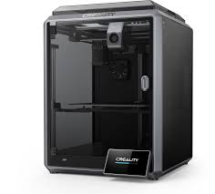
Figure 10.1: K1 MAX 3D Printer

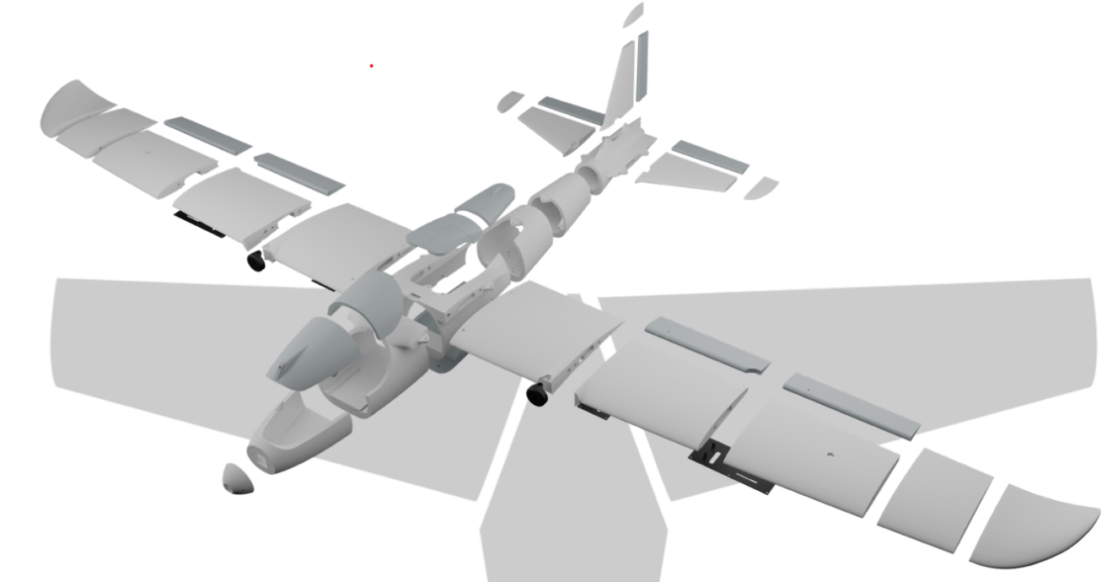
Figure 10.2: All Parts in UAV

Materials Used in Fabrication
Three different filament materials were used across the airframe, with each one chosen to suit the specific mechanical and functional demands of the part being printed.
- Lightweight PLA (LW-PLA): LW-PLA was the primary material for the large aerodynamic surfaces, including the wing sections, fuselage panels, and tail assembly. When printed at a raised nozzle temperature, this filament foams internally, expanding in volume and significantly reducing part density while largely preserving external dimensional accuracy. This property made it especially valuable for a weight-critical eVTOL airframe, since it allowed large-area parts such as the wings and blended fuselage to be produced with a substantial mass saving compared to solid PLA, directly supporting the thrust-to-weight and endurance targets of the design.
- PLA+: PLA+ was used for components that needed to be stiffer and tougher than the foamed LW-PLA parts but did not carry the same weight-saving priority, such as internal mounting brackets, hatch and canopy fittings, and other structural fixtures. Compared to standard PLA, PLA+ offers improved impact resistance and layer adhesion, giving these smaller functional parts better resilience to handling loads and vibration during flight testing.
- PETG: PETG was reserved for parts exposed to higher mechanical stress or requiring greater durability, such as the payload bay and load-bearing mounting points. Its higher impact strength, flexibility, and resistance to cracking made it a suitable choice for areas where the brittleness of standard PLA-based filaments would be a liability.

Structural Reinforcement
Because foamed LW-PLA exhibits lower absolute flexural stiffness compared to standard polymers, the airframe was reinforced with an internal structural skeleton composed of high-strength carbon fiber and lightweight aluminum rods. These rods were routed through the hollow interior of the solid body along the main load paths of the wing and fuselage, running spanwise through the wing sections and lengthwise along the fuselage centerline. Channels matching the rod diameters were built directly into the 3D-printed parts so that each rod could be slid into place and epoxy-bonded to the surrounding print during assembly, tying the individually printed segments into a single continuous load-bearing structure rather than relying on the printed shell alone to carry flight loads.
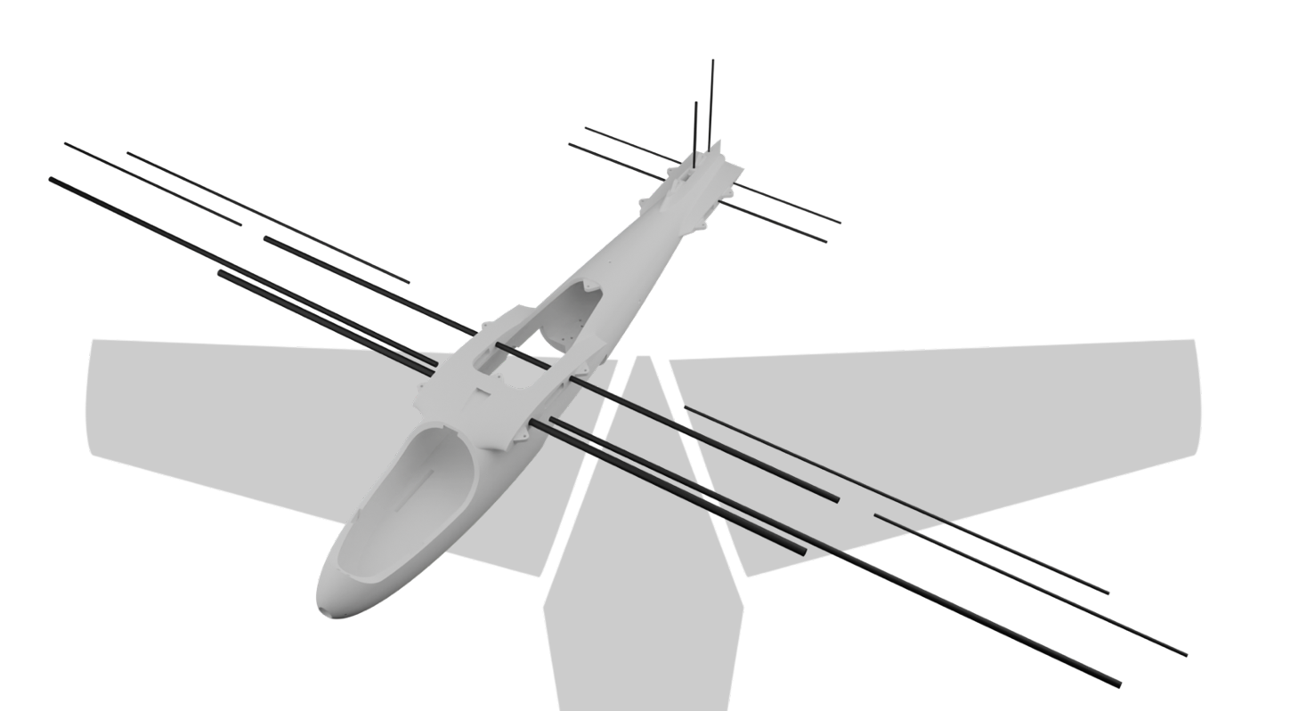
Figure 10.3: Reinforcement

Electronic Components

Battery
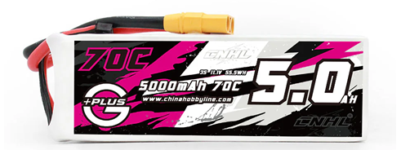
Figure 10.4: Battery

CNHL G+Plus 5000mAh 11.1V 3S 70C Lipo Battery with XT90 Plug is used to power this aircraft. It is mounted front of the UAV

Flight Controller
MATEKSYS H743-WING V3 was used as the flight controller board. The specifications of the flight controller board and are shown below

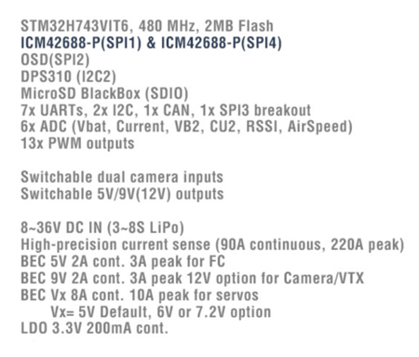
Figure 10.5: Specifications of the MATEKSYS H743-WING V3

The flight controller was soldered and attached layer by layer and it consist of three layers. The three layers are, 1. Power distribution board 2. USB Type-C & Buzzer Extender 3. Flight controller board.
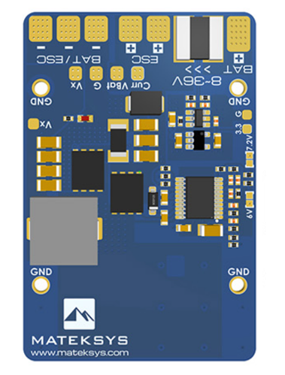
Figure 10.6: Power distribution board
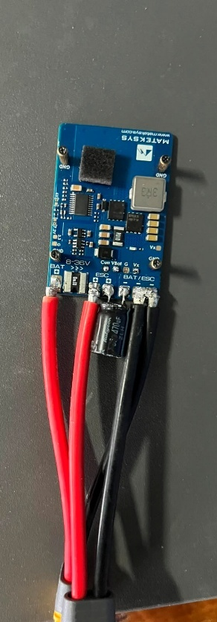
Figure 10.7: Soldered board
The wiring diagram of the flight controller board is shown below,
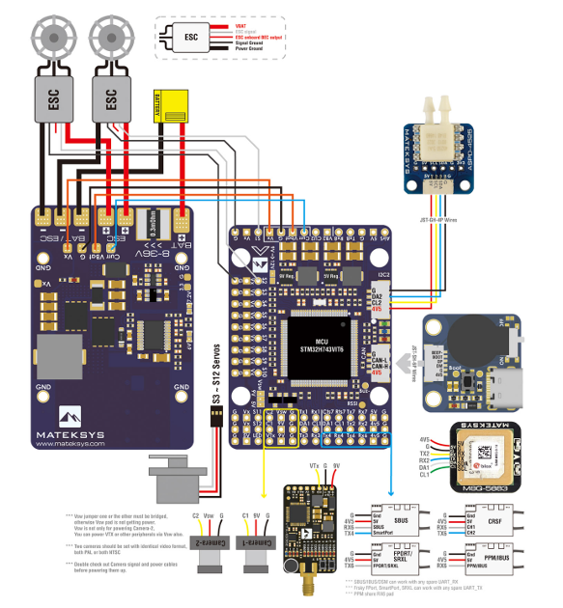
Figure 10.8: Wiring diagram of the flight controller board

Electronic speed controller
Figure 10.9 shows the ESC used on UAV, a 4-in-1 unit four independent motor drivers built onto a single board, though only three are actually wired up, one per rotor. It sits between the battery and the motors, and its job is to take the throttle command the flight controller sends for each motor and turn the battery's DC power into the switched output that spins that motor at the requested speed.
It needs to handle a fair amount of current, which is why the motor leads soldered to the board are noticeably thicker than the signal wiring elsewhere on the aircraft. There is also a small electrolytic capacitor wired across the input leads (visible top-left in the photo, a Rubycon rated at 35V, 680µF) to smooth out the current spikes that come with sudden throttle changes, so the rest of the power system does not see a voltage dip every time the motors demand more current.
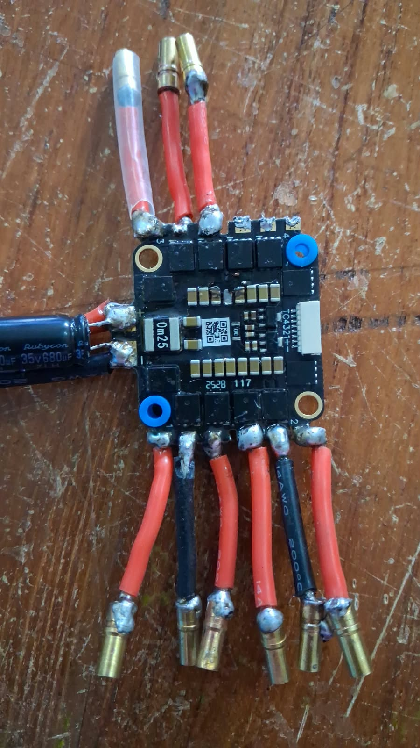
Figure 10.9: The 4-in-1 ESC

GPS module
The GPS unit on UAV is a BZGNSS BZ-251 (Figure 10.10), a small GNSS receiver that connects to the flight controller through a six-wire connector TX, RX, ground, 5V, SCL and SDA. It gives the flight controller a live position fix: latitude, longitude, altitude and ground speed. Anything past basic manual flight relies on this position hold, loiter, waypoint missions and return-to-launch all need a working GPS lock before ArduPilot will even let you switch into those modes.
Placement matters more for this module than for almost anything else on the aircraft, since it needs a clear view of the sky and some separation from the ESC and power wiring, both of which are electrically noisy enough to degrade a GNSS signal if the module sits too close to them.
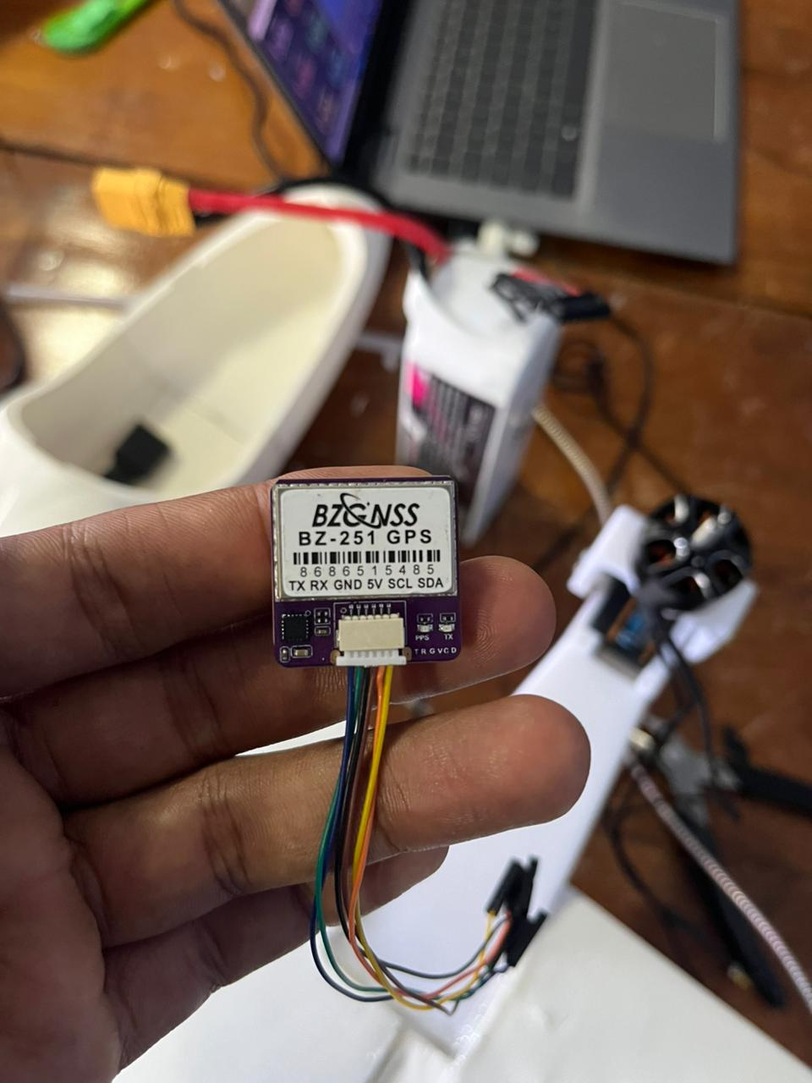
Figure 10.10: The GNSS/GPS module

Receiver
Figure 10.11 shows the RC receiver the small board with the bundle of thin antenna wires trailing off it. It picks up the signal from the transmitter the pilot holds on the ground and passes the resulting stick and switch positions to the flight controller as a set of channel values. It is the only part of the aircraft that talks to the ground pilot directly; every manual command starts here.
The multiple wires are its antennas. Most receivers use two or more for exactly this reason if the aircraft's orientation puts one antenna in a null spot, the other keeps the link alive. Since losing this connection mid-flight means losing manual control, that redundancy is not something to skip.
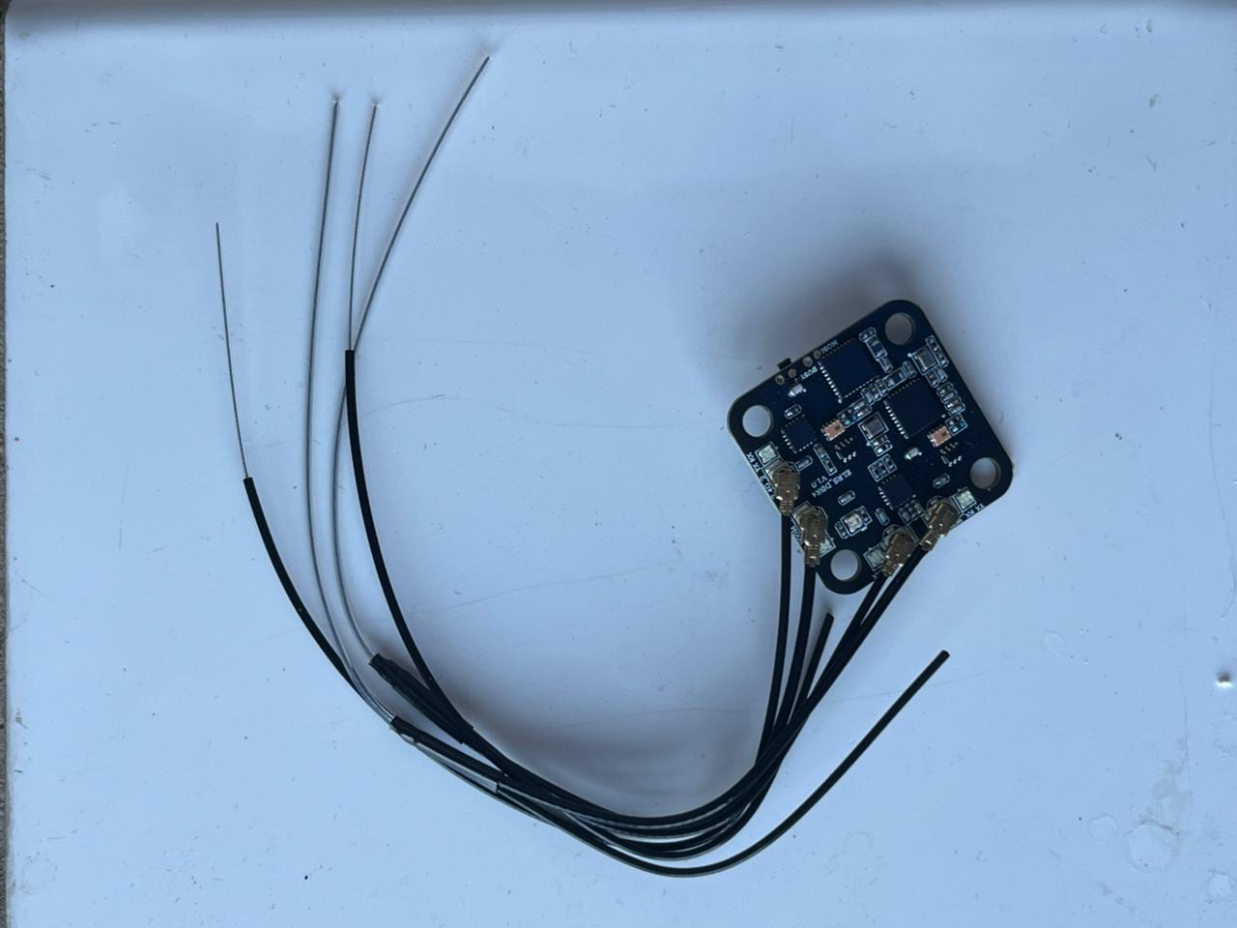
Figure 10.11: The RC receiver

Wiring diagram

Figure 10.12 shows how all of the above, along with the battery, UBEC, motors and flight controller, connect to one another. There are really two overlapping diagrams here: a power path and a signal path, and it is easier to read them separately.
The dashed maroon lines are power. The battery feeds the UBEC directly, and the UBEC regulates that down to a steady 5V rail that runs out to the receiver and to all ten of the CS and TS channels. The battery also feeds the ESC directly at full voltage, since the ESC does its own conversion for the motors rather than drawing from the UBEC's 5V rail.
The solid black lines are signal, and nearly all of them lead to the flight controller. The receiver's channel values, the seven CS1–CS7 inputs and the three TS1–TS3 channels all feed into it, and it sends commands back out to the ESC. The CS channels report the position of the aircraft's control surfaces — ailerons, elevator, rudder and so on — back to the flight controller. The TS channels work both ways: each carries the commanded tilt angle out to one rotor's tilt actuator and the measured angle back, which is how the flight controller confirms a propeller has actually reached the angle it was told to, rather than assuming it has, during a transition.
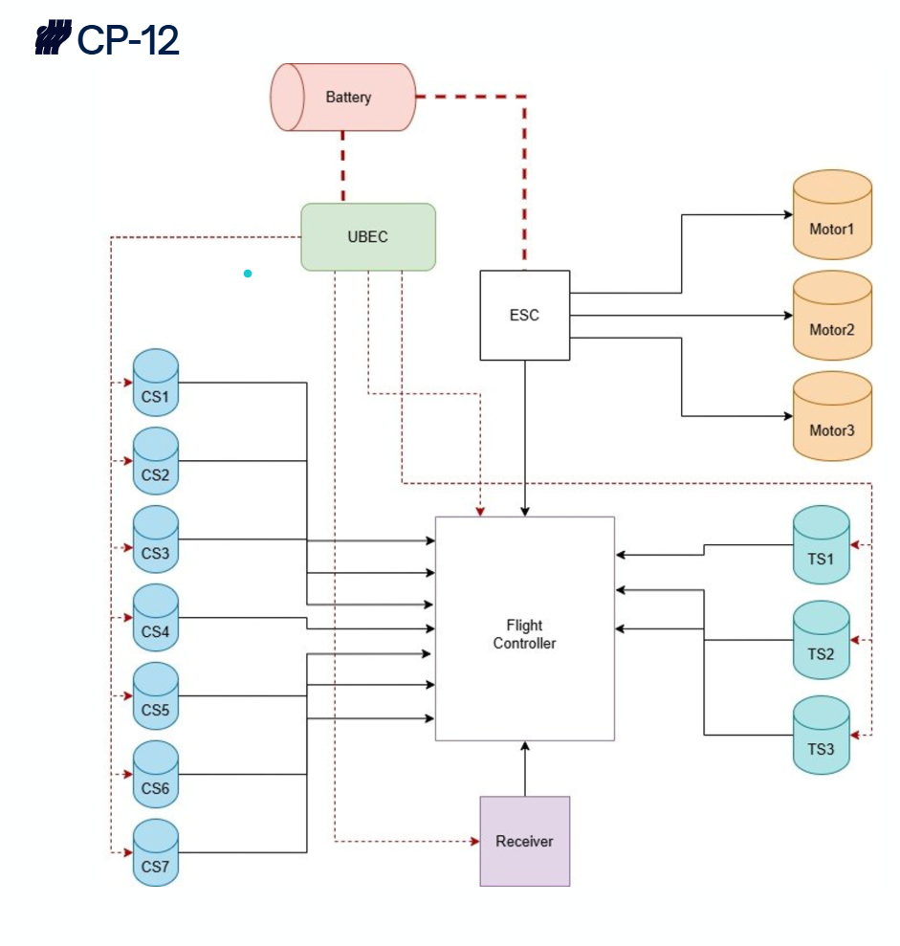
Figure 10.12: Wiring Diagram

ArduPilot Configuration, Integration, and Tuning

Flight Controller and Firmware Overview

ArduPilot

ArduPilot is an open-source autopilot software suite whose origins trace to 2007, when a prototype drone autopilot built on LEGO Mindstorms hardware was released to the DIY Drones hobbyist community; the project's first dedicated code repository followed in 2009. It has since grown, through contributions from a large global community of engineers, academics, and hobbyists, into one of the most widely used autopilot systems in the world, reportedly running on over one million vehicles. Rather than targeting a single vehicle type, ArduPilot is organised into several vehicle-specific firmware builds ArduCopter for multirotors, ArduPlane for fixed-wing and hybrid VTOL aircraft, ArduRover for ground vehicles, and ArduSub for underwater vehicles, among others that share a common core of navigation, estimation, and safety code. This project uses ArduPlane, specifically its QuadPlane hybrid mode, because UAV must be controlled as a multirotor in hover and as a fixed-wing aircraft in cruise within a single flight.
11.1.2 Flight Controller Hardware and Firmware Configuration
The UAV uses a Matek H743-Wing flight controller (FC) running ArduPilot, configured with the ArduPlane firmware build in QuadPlane mode. QuadPlane is ArduPilot's hybrid vehicle class: a single firmware image runs a multicopter-style rate/attitude controller for hover and transition alongside a conventional fixed-wing controller for cruise flight, with the active control law selected by flight mode. This is the appropriate firmware choice for the airframe, since all three rotors are used for both vertical lift and forward propulsion rather than having dedicated, non-tilting cruise motors.
The H743-Wing is built around a single STM32H743 microcontroller. Two properties of this architecture are treated as standing project conventions rather than one-off configuration notes, because they were sources of early integration error:
1) Single-MCU bidirectional DShot. Because the board uses one MCU for all outputs, bidirectional DShot telemetry is available on every motor output rather than being restricted to a MAIN or AUX output group, as is the case on dual-MCU boards. This simplifies ESC wiring choices but means output-group timer conflicts must still be checked manually against the board's pinout documentation.

2) UART-to-SERIAL mapping is non-obvious. The physical UART silkscreen labelling on the H743-Wing (e.g., “T3/R3”) does not correspond one-to-one with ArduPilot's logical SERIALn parameter numbering. Every peripheral integrated on this board (receiver, VTX, GPS) was cross-checked against the board manufacturer's pin map before assigning SERIALn_PROTOCOL parameters, and this cross-check is treated as a mandatory step for any future UART-connected peripheral

AIRFRAME CONFIGURATION
The VECTOR V1 is a fixed-wing airframe with three rotors: two wing-mounted motors and one motor elevated on a mast above the vertical stabiliser. All three motors tilt through the same forward-and-up range, from thrust-vertical in VTOL modes to thrust-forward in cruise, so there are no separate dedicated cruise motors. Fig. 11.1 shows the motor placement in plan and side view together with the tilt range of each motor.
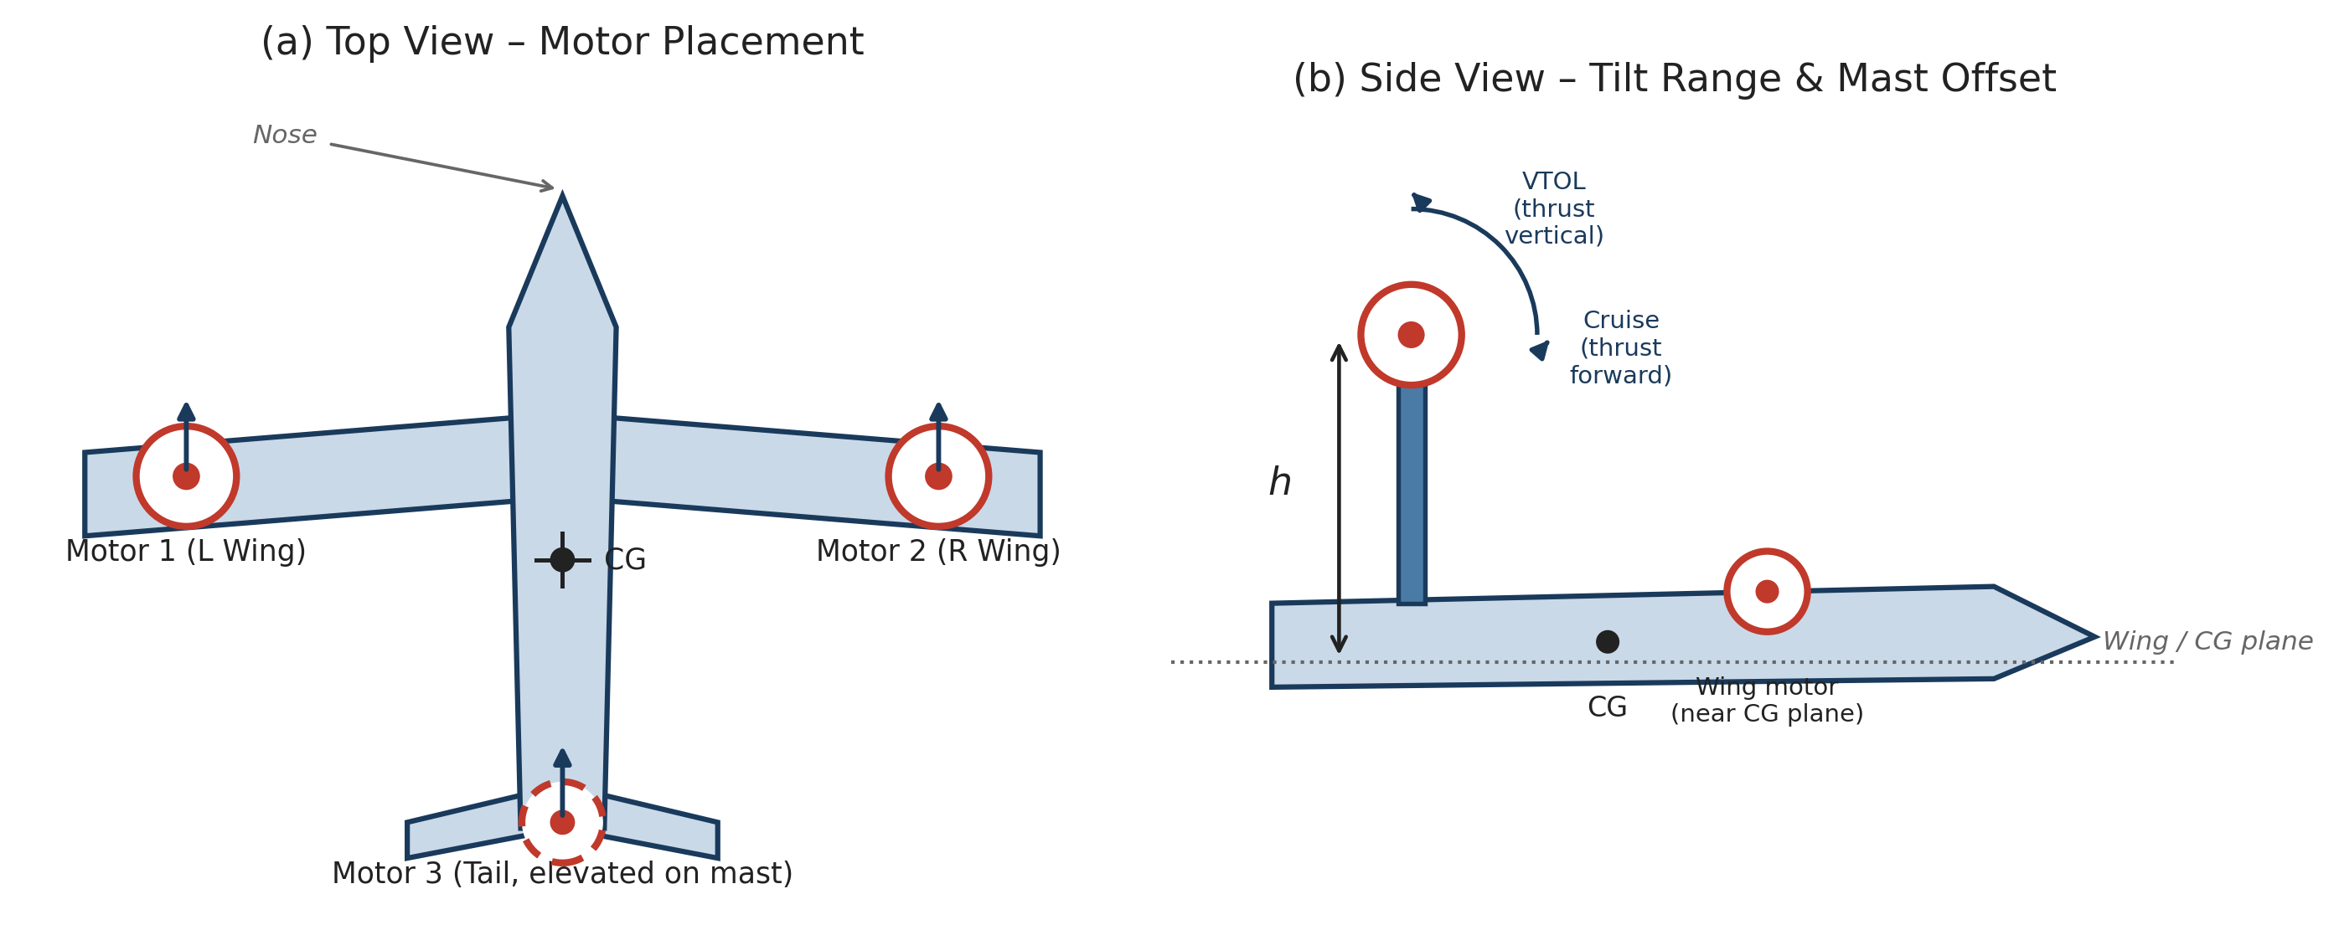
Figure 11.1: VECTOR V1 tricopter tiltrotor layout: motor placement (top view) and tilt range with mast offset (side view)

.

- Frame Class and Tilt Enable
The vehicle is configured as ArduPilot QuadPlane frame class 7 (tricopter), the frame class ArduPilot designates for three-motor VTOL configurations, with tilt-rotor support enabled. Under this frame class, ArduPilot's motor-output convention assigns the two front motors to outputs 1 and 2 and reserves output 3 as an unused placeholder inherited from the generic quad-output numbering, assigning the rear motor to output 4 [4]. This convention is the reason the tilt and ESC bitmasks used on this build (Section 3.3) reference output 4 rather than output 3 for the tail motor.
- Vectored-Yaw Tilt Type
Q_TILT_TYPE is set to 2 (“vectored”), which enables independent tilt-servo control for yaw authority in VTOL modes rather than relying solely on differential rotor thrust or a separate yaw servo [1]. Combined with continuously-variable tilt servos (as opposed to a binary retract-style mechanism), this allows the flight controller to command small, continuous tilt-angle offsets on the wing motors to generate yaw moments during hover and transition, in addition to commanding the bulk tilt angle that governs the VTOL-to-cruise transition.
- Tilt Mask
Q_TILT_MASK is set to 11 (binary 1011), which selects motor outputs 1, 2, and 4 — the two wing motors and the tail motor — as tilting motors, with output 3 excluded consistent with the tricopter output convention described above. All three physical motors on this airframe are therefore fully tilting; there is no fixed-mount motor.
Table 11-1: Airframe and Tilt Configuration Parameters
Parameter | Value | Purpose
Q_ENABLE | 1 | Enables QuadPlane (hybrid VTOL/fixed-wing) firmware mode
Q_FRAME_CLASS | 7 (Tri) | Selects the tricopter VTOL frame class
Q_TILT_ENABLE | 1 | Enables tilt-rotor support within QuadPlane
Q_TILT_TYPE | 2 (Vectored) | Enables tilt-servo-vectored yaw control in VTOL modes
Q_TILT_MASK | 11 (0b1011) | Marks motor outputs 1, 2 and 4 as tilting

Esc and Motor Configuration
All three motors are driven from a single Hobbywing XRotor 65 A 4-in-1 ESC (BLHeli_32, 6S “Lite” variant), powered from a 6S LiPo pack. Consolidating three motor drives onto one 4-in-1 ESC simplifies the power-distribution wiring at the cost of placing all three drive stages on a single board, which is a relevant consideration for the fault-isolation.
Table 11-2: MOTOR AND ESC SPECIFICATIONS
Component | Specification
Motor | Xrotor 2812, 1100 KV × 3
ESC | Hobbywing XRotor 65 A 4-in-1, BLHeli_32, 6S “Lite”
Battery | 6S LiPo
Motor protocol | Bidirectional DShot (SERVO_BLH_BDMASK = 7, outputs 1–3)
Flight controller | Matek H743-Wing (STM32H743, single MCU)

Bidirectional DShot is enabled with SERVO_BLH_BDMASK = 7 (binary 0111), covering the three physical ESC motor outputs used on this build. Bidirectional DShot returns eRPM telemetry from each motor to the flight controller, which is used both for motor-health monitoring and, where configured, for RPM-based dynamic notch filtering of the gyro signal As with the tilt mask, the exact output numbering for the BLHeli_32 bitmask is independent of the Q_TILT_MASK numbering in Section 3.2, since one addresses ESC/motor outputs and the other addresses which of those motors are mechanically tilting; the two bitmasks were verified separately in BLHeli_32 Configurator and Mission Planner respectively.

RC Link and Telemetry
Command and telemetry are carried over a single ExpressLRS (ELRS) link rather than separate RC and telemetry radios. The ground side is a RadioMaster TX16S transmitter running EdgeTX with a Radiomaster Nomad ELRS module fitted in the JR bay; the air side is an ELRS receiver wired to the flight controller's SERIAL4 UART, configured for combined RC-channel and MAVLink telemetry output over that one link.

Table 11-3: RC LINK AND TELEMETRY PARAMETERS
Parameter | Value | Purpose
SERIAL4_PROTOCOL | 2 (MAVLink2) | Presents SERIAL4 to the FC as a MAVLink telemetry port
SERIAL4_BAUD | 460 (460 800 bps) | Matches the ELRS receiver's MAVLink baud rate
RSSI_TYPE | 5 | Reads link-quality/RSSI from the telemetry stream
GPS_TYPE2 | 0 (disabled) | Frees SERIAL4 from its default GPS2 role on the H743-Wing

The GPS_TYPE2 = 0 setting is necessary because SERIAL4 is the default second-GPS port on the H743-Wing; leaving GPS_TYPE2 at its default would conflict with the receiver's use of that UART for RC and telemetry. Operating the receiver in MAVLink mode also forces EdgeTX into Hybrid switch mode, which can move switch-channel assignments relative to a prior CRSF or Wide-mode configuration, this was re-verified in the transmitter mixer after enabling MAVLink telemetry. The receiver is physically wired to the H743-Wing's T3/R3 UART pads, which correspond to the FC's SERIAL4 port per the board's pin map rather than any UART numbering implied by the silkscreen label alone
For bench configuration, the Nomad module's USB-C port is connected directly to the ground-station PC as a virtual COM port into Mission Planner, in preference to the module's WiFi access point, which was not discoverable from the bench PC during setup. This wired path is used to confirm that RC override and MAVLink telemetry operate simultaneously over the single ELRS link before proceeding to powered bench tests.

Control-Loop Tuning Methodology

PID Control Theory Fundamentals
Before presenting the project-specific tuning sequence, it is useful to establish the general control-theory vocabulary used throughout this section. A Proportional-Integral-Derivative (PID) controller is the standard mechanism ArduPilot uses to convert a tracking error into a corrective control output at every level of its cascaded control architecture (rate, attitude, and outer-loop position controllers). Fig. 3.5 shows a generic single-axis feedback loop augmented with a feed-forward path, in the same general form used by ArduPilot's rate controllers.
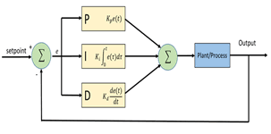
Figure 11.2: Generic PID feedback control loop with an added feed-forward (FF) path

At every instant, the controller measures an error signal e(t), the difference between the desired setpoint r(t) and the measured process variable y(t), and computes a control output u(t) according to the classical continuous-time PID law:
u(t) = K_{p} e(t) + K_{i} ∫e(τ) dτ + K_{d} de(t)/dt (2)
where Kp, Ki, and Kd are the proportional, integral, and derivative gains. Each term contributes a distinct, complementary behaviour to the closed loop:
Proportional (P). Produces an output directly proportional to the instantaneous error, giving an immediate corrective push. Used alone, a P controller cannot fully eliminate a constant steady-state error, since some non-zero error is required to sustain a non-zero output against a persistent load or bias. Increasing Kp reduces rise time and steady-state error but increases overshoot, and beyond some critical gain it drives the loop into sustained oscillation or outright instability.
Integral (I). Accumulates error over time, so even a small persistent error continues to increase the output until the error is driven to zero — this is what allows a PID loop to achieve zero steady-state error where P alone cannot. The cost is added phase lag, which tends to increase overshoot and settling time if Ki is too large, and a risk of “integral windup”: if the actuator saturates (e.g., a motor pinned at maximum output) while error persists, the accumulated integral term can grow unboundedly and produce a large, delayed overshoot once the actuator comes off its limit.
Derivative (D). Acts on the rate of change of the error, effectively anticipating where the error is heading and damping the response before it overshoots — D generally reduces overshoot and settling time. Its principal drawback is sensitivity to noise: differentiating a noisy signal amplifies that noise, which is the underlying reason a well-configured gyro notch filter is a prerequisite for D-gain tuning (Section 3.7-B) rather than an optional refinement.
Table 11-4: QUALITATIVE EFFECT OF INCREASING EACH GAIN TERM
Gain Increased | Rise Time | Overshoot | Settling Time | Steady-State Error
Kp | Decreases | Increases | Small increase | Decreases
Ki | Decreases | Increases | Increases | Eliminated
Kd | Minor decrease | Decreases | Decreases | No direct effect

This table summarises the classical, qualitative trends used to reason about gain adjustments; it assumes the other two gains are held fixed and that the loop remains stable, and it is the same qualitative reasoning underlying the “increase-until-oscillation, then back off” empirical tuning heuristic used throughout
Feed-forward (FF). A pure PID loop can only react after an error already exists. A feed-forward term instead computes an anticipatory contribution directly from the setpoint (or commanded rate) itself, independent of any measured error, and adds it to the PID output:
u(t) = K_{ff} r(t) + [PID terms from Eq. (2)] (3)
Because the FF term does not depend on error, it does not add feedback gain to the loop and therefore does not, by itself, push the loop toward instability the way increasing Kp or Ki can. This is precisely why the project's tuning order sets FF before P and D on the vectored yaw axis: a well-set FF term does most of the work of tracking a moving command, leaving the feedback gains to handle only the residual error and disturbance rejection a smaller, better-conditioned tuning problem.
Finally, ArduPilot's attitude controllers are cascaded rather than single-loop: an outer angle-error controller produces a desired rate, which becomes the setpoint r(t) for an inner rate-PID loop of the form shown in Fig. 11.2 and, in its project-specific form, in Fig. 11.3 below. As with cascaded loops generally, the inner (rate) loop must be tuned to respond substantially faster than the outer (angle) loop it serves; this is a standing reason to tune from the inside out rate first, then angle rather than the reverse.

Tuning Order

Yaw authority on this airframe comes entirely from vectored tilt-servo deflection rather than differential motor speed, so the yaw rate controller is the axis most specific to this build and receives the most detailed tuning treatment in this chapter. Fig. 11.3 shows the simplified rate-controller cascade for the yaw axis, following the general PID-plus-FF structure
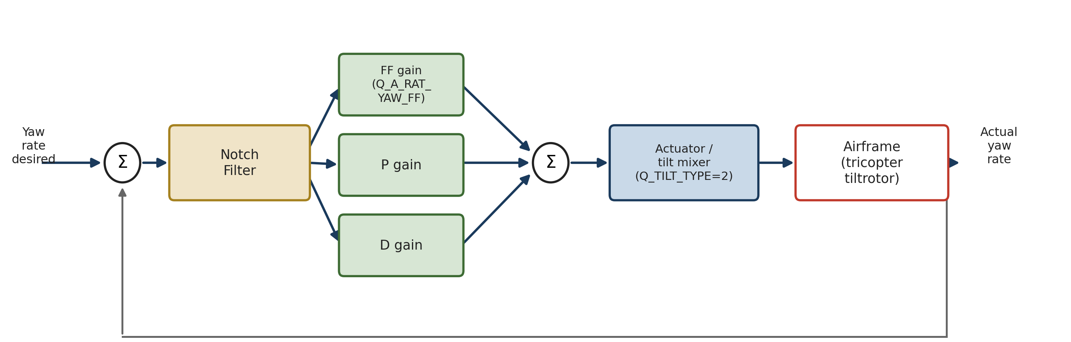
Figure 11.3: Simplified ArduPlane VTOL yaw rate-controller cascade, from commanded yaw rate through the notch filter and FF/P/D gain stages to the tilt mixer and airframe, with gyro feedback.
ArduPilot's general QuadPlane VTOL tuning process establishes a stable hover and a correctly configured gyro notch filter before any rate-PID adjustment is made, since an unfiltered, noisy rate signal will corrupt subsequent gain tuning. Building on that baseline, the project follows a fixed order for the yaw axis specifically: notch filter verification, then feed-forward (FF) gain, then proportional (P) gain, then derivative (D) gain . FF is set before P and D because, on a vectored-tilt yaw axis, an under-set FF gain manifests as a large apparent tracking lag that could otherwise be mistaken for a P/D deficiency and chased with the wrong gains.
With Q_A_RAT_YAW_FF left near its low default, slow yaw response to stick input is expected behaviour and not, by itself, evidence of a fault elsewhere in the control chain; ArduPilot's tilt-vectored yaw guidance confirms this axis is tuned separately from the standard roll/pitch process
11.5.3 Diagnosing the Yaw Response Delay

An approximately one-second apparent delay between yaw stick input and the onset of yaw rate was observed during bench/early testing. Q_PLT_Y_RATE_TC was identified as the primary suspect, since an elevated value of this time-constant parameter directly slows the commanded-rate shaping ahead of the rate controller; the corrective action is to check this parameter and reduce it toward the 0.1–0.15 s range if it is found elevated. Fig. 11.4 illustrates the diagnostic concept the qualitative shape of an under-tuned versus a corrected response for explanatory purposes; it is not measured flight-log data.
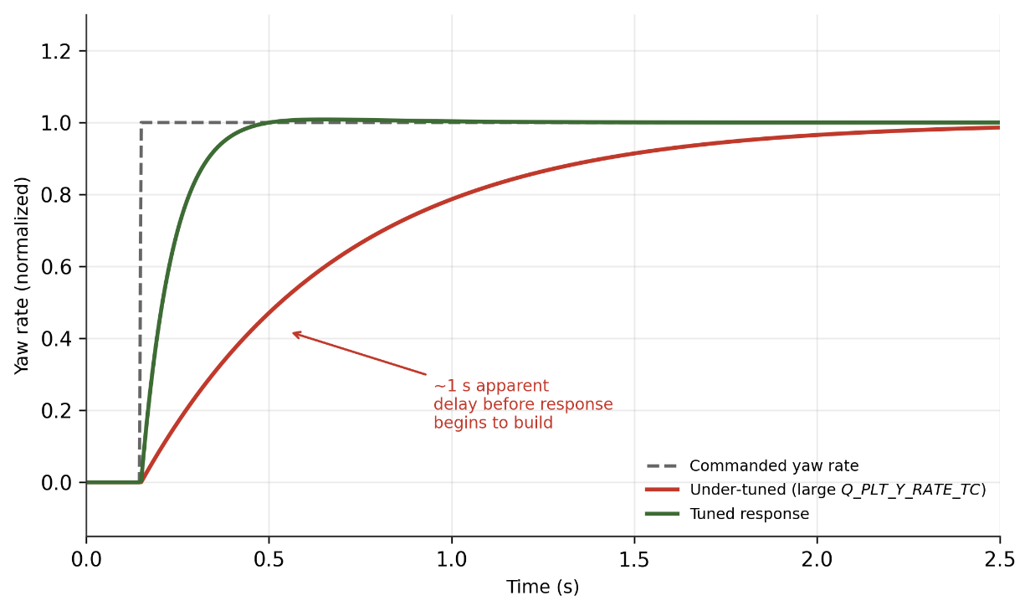
Figure 11.4: Conceptual illustration of the yaw response delay diagnosis and its resolution. Curve shapes are illustrative only, intended to convey the diagnostic method not measured flight-log data.
To distinguish a genuine input-shaping lag from a slower controller-response lag, the diagnostic method is to compare the logged desired yaw rate (RATE.YDes) against the logged actual yaw rate in the same flight log: a delay that appears between the pilot's stick movement and RATE.YDes itself points to input shaping (i.e., Q_PLT_Y_RATE_TC), whereas a delay between RATE.YDes and the actual measured rate points to the rate controller's P/D/FF tuning instead.

FLIGHT TEST
Testing proceeded in three stages: a ground-level leveling check, a VTOL hover test, and a horizontal (forward) flight test following transition. In VTOL mode, all three propellers are oriented to direct thrust vertically upward, allowing the aircraft to take off, hover, and land without a runway. During transition to forward flight, the propellers tilt forward from the vertical position, converting vertical thrust into forward thrust; as airspeed builds, lift is progressively taken up by the fixed wing, allowing the aircraft to sustain efficient horizontal cruise flight. Both the VTOL hover phase and the horizontal flight phase were each flown twice: an initial test that surfaced control issues, followed by a second test after PID controller tuning was applied to address them.

Ground Test-Leveling Check
Before any flight was attempted, the aircraft was placed on the test field with all three propellers in the vertical (VTOL) orientation to carry out a leveling check. This step verifies motor alignment, propeller balance, and airframe leveling, ensuring the flight controller's attitude reference is accurate before the UAV is armed.
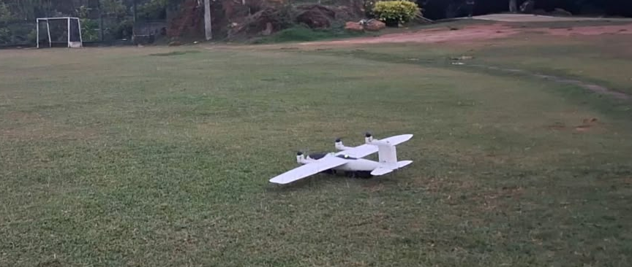
Figure 12.1: Ground leveling check - VTOL configuration, propellers vertical.

Vtol Flight Test

Overview
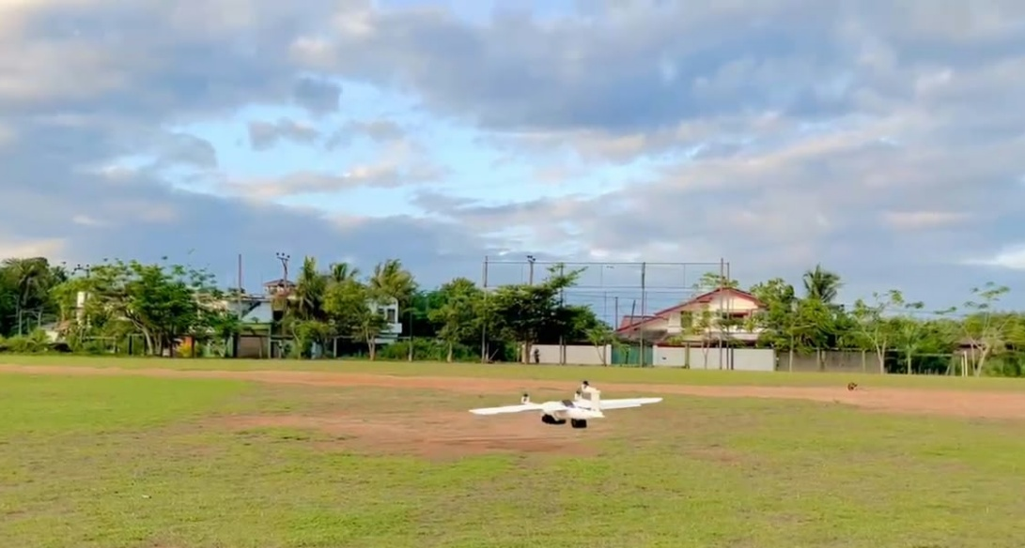
Figure 12.2: VTOL take-off/hover - all three propellers directed for upward thrust.

The first VTOL attempt lifted the aircraft off the ground under vertical thrust from all three rotors, but stable hover could not be sustained. The following issues were logged and used to guide subsequent controller tuning:

VTOL Test 1
The flight-log attitude traces (desired vs. actual, from the onboard controller) were reviewed to diagnose the instability seen in Test 1.
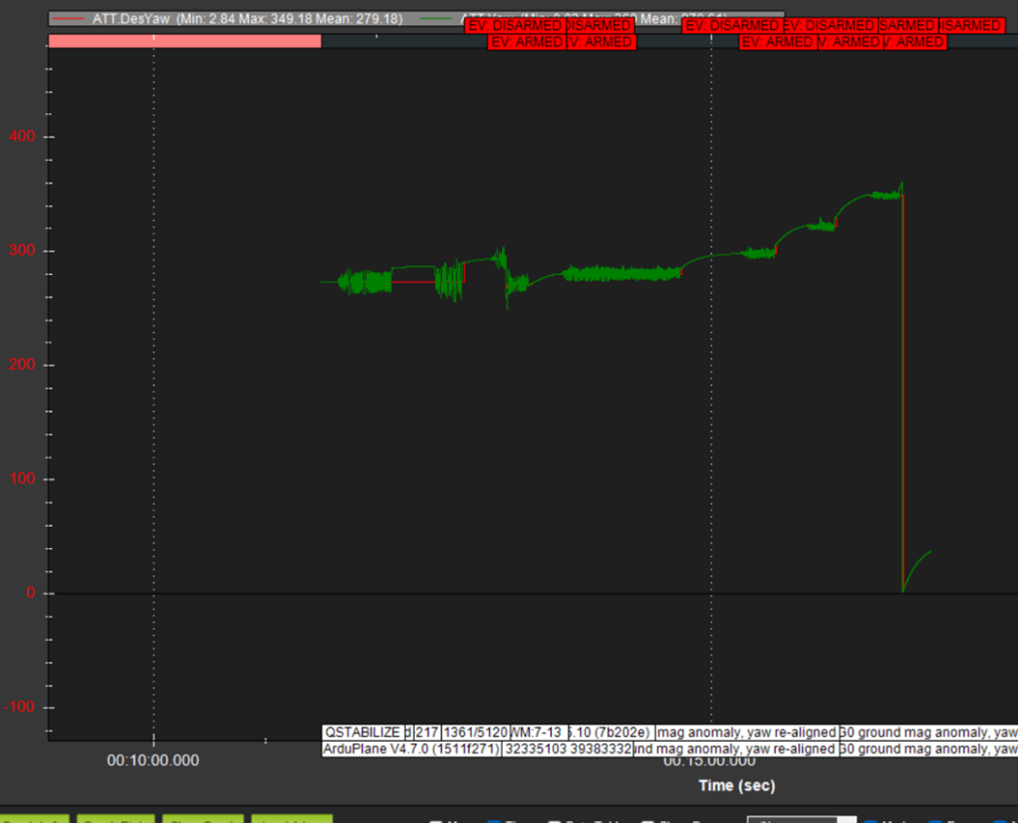
Figure 12.3: VTOL Test 1 - Desired Yaw (red) vs. actual Yaw (green).

The actual yaw oscillates sharply around the commanded value through most of the log, then drifts away from the desired heading toward the end of the segment, coinciding with a magnetometer anomaly flagged in the flight log. This points to both a control-tracking issue and a possible compass/magnetic-interference contribution.
Observation:
- Actual yaw does not immediately follow desired yaw
- Yaw response delay observed
- Yaw-control tuning required
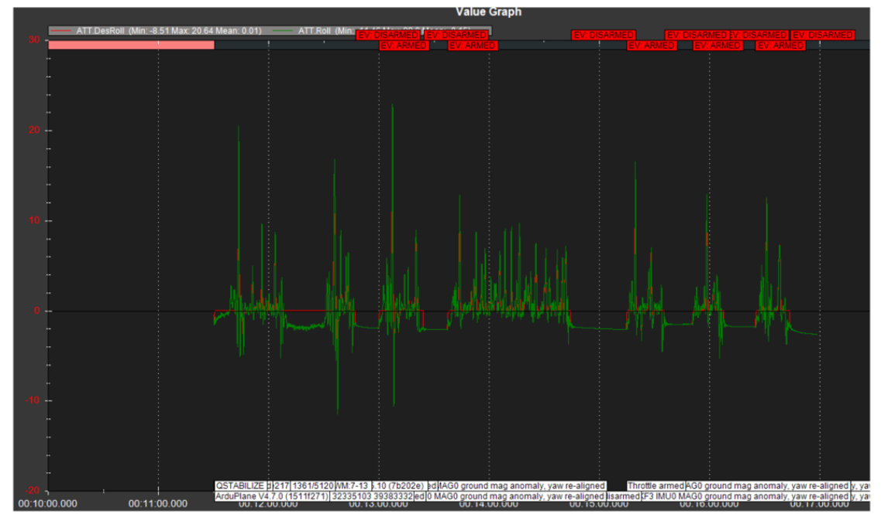
Figure 12.4: VTOL Test 1 - Desired Roll (red) vs. actual Roll (green).

Roll shows large, sharp spikes departing from the commanded (near-zero) roll angle, rather than settling to a steady hover attitude.
Observation:
- Large roll fluctuations
- Actual roll deviates from desired roll
- Indicates lateral instability
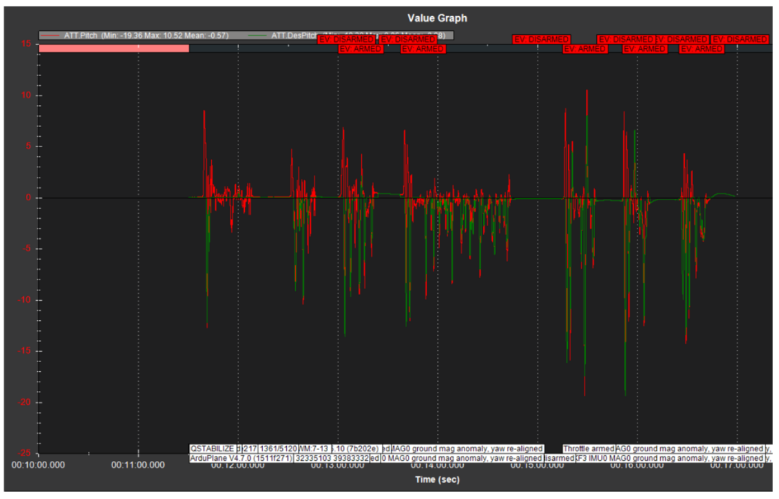
Figure 12.5: VTOL Test 1 - Desired Pitch (red) vs. actual Pitch (green).

Pitch exhibits a similar pattern to roll, with repeated large-amplitude excursions from the commanded pitch angle.
Observation:
- Significant pitch fluctuations
- Poor attitude tracking
- Contributed to unstable VTOL condition
PID tuning required

VTOL Test 2
Following PID tuning informed by the Test 1 log analysis, a second VTOL test was flown.
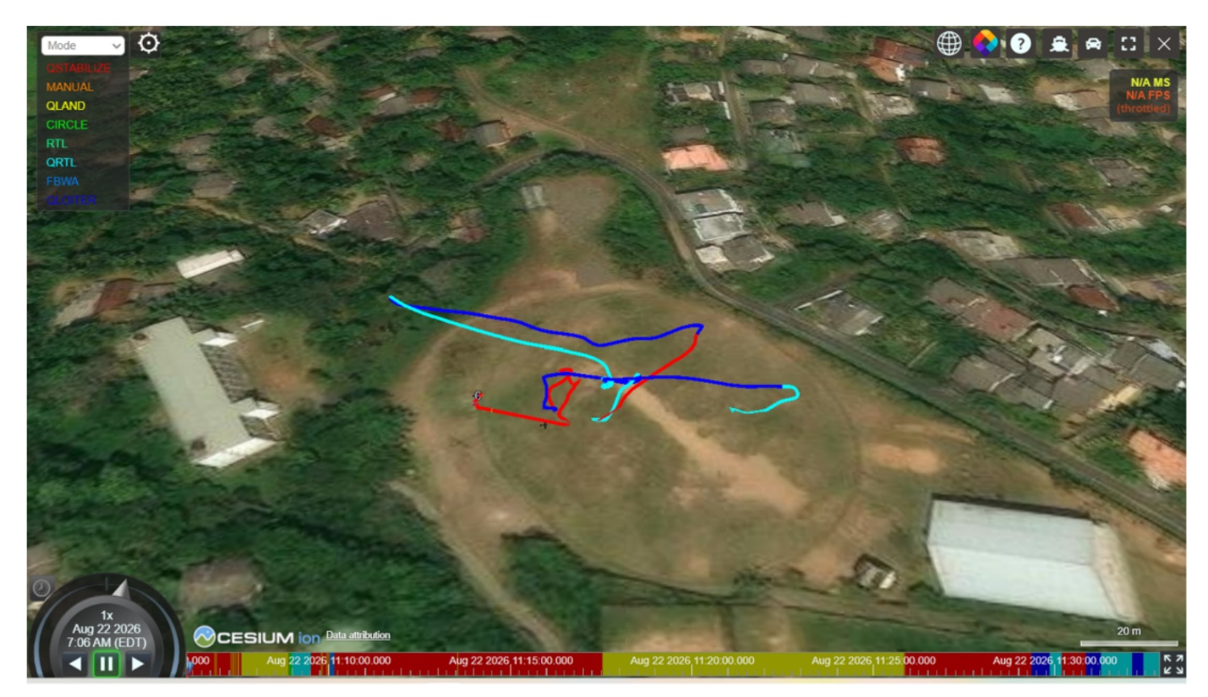
Figure 12.6: VTOL Test 2 - recorded ground track over the test field.

The ground track shows the aircraft cycling through QSTABILIZE, CIRCLE, RTL/QRTL and QLOITER modes while repositioning and hovering. Compared with the erratic behaviour of Test 1, the loops are tighter and more contained, consistent with improved attitude control.
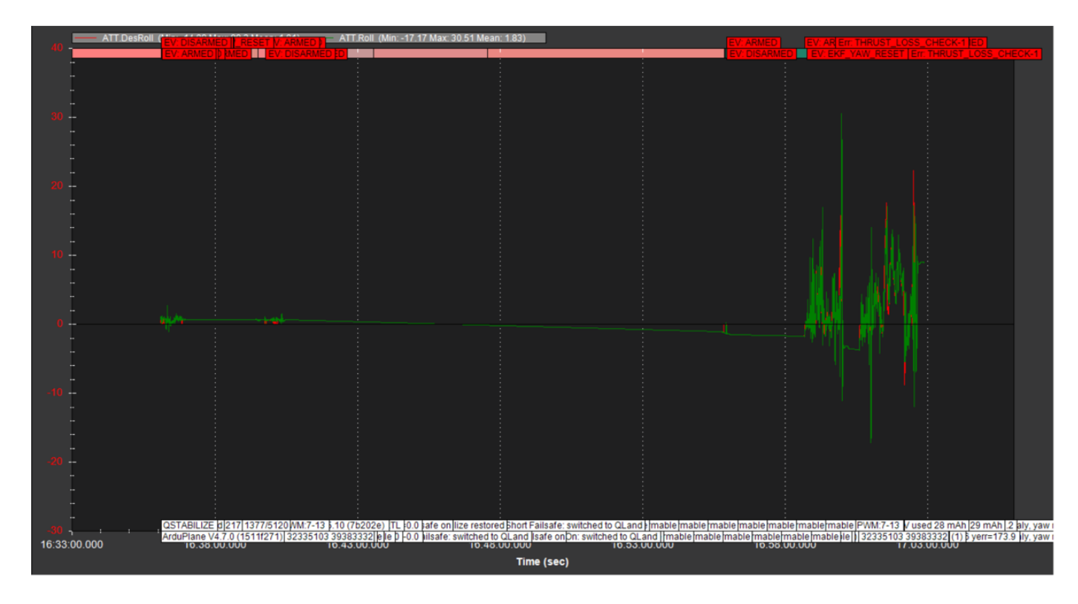
Figure 12.7: VTOL Test 2 - Desired Roll vs. actual Roll, after tuning.
Observation:
- Reduced roll oscillation
- Actual roll follows desired roll more closely
- Improved lateral stability
- PID tuning effective
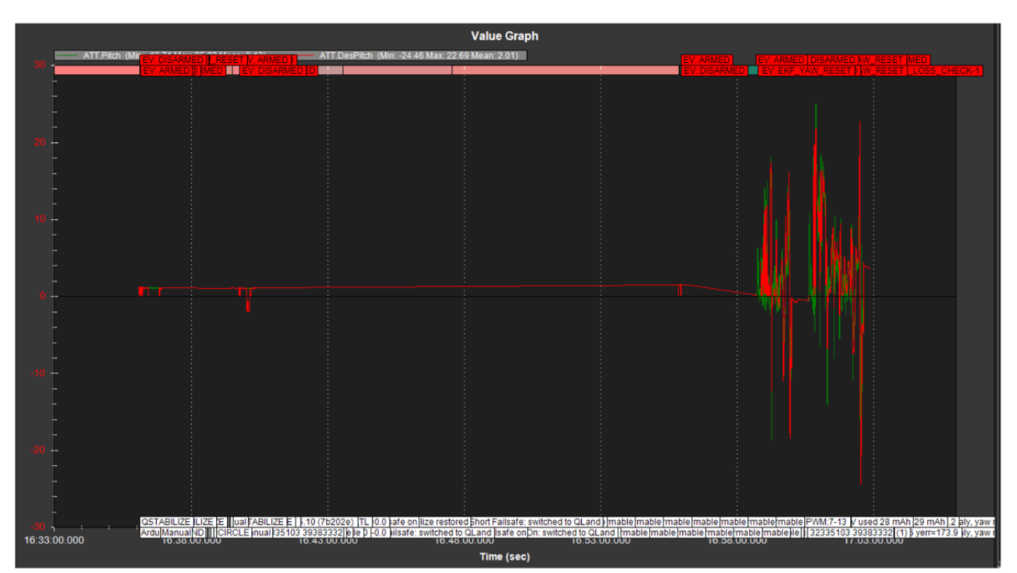
Figure 12.8: VTOL Test 2 - Desired Pitch vs. actual Pitch, after tuning.

Observation:
- Improved pitch stability
- Reduced attitude fluctuations
- Better tracking of desired pitch
- More stable VTOL response
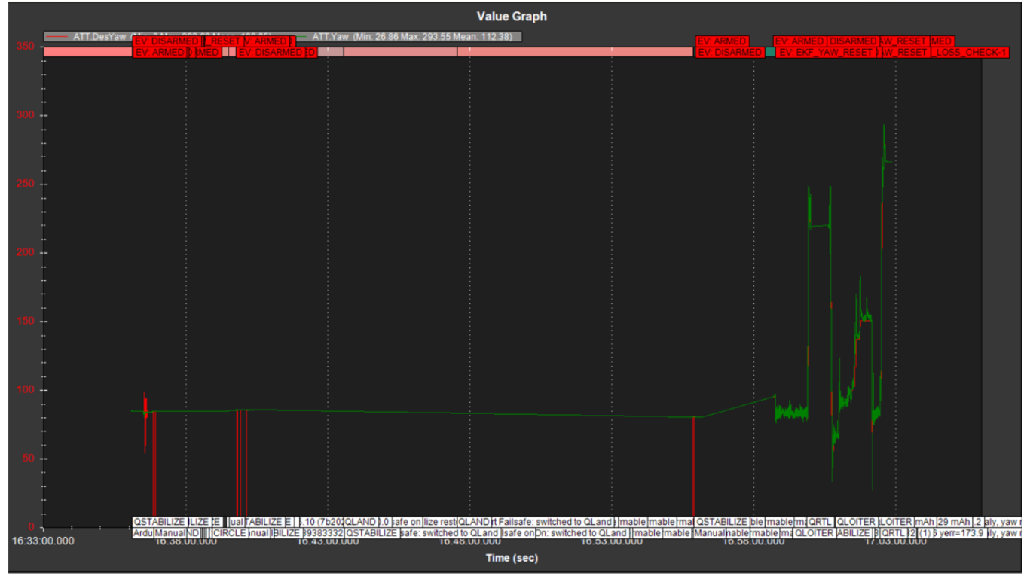
Figure 12.9: VTOL Test 2 - Desired Yaw vs. actual Yaw, after tuning.
Observation:
- Improved yaw response
- Reduced yaw tracking delay
- Actual yaw follows desired yaw more effectively
- Yaw-control adjustment successful

Horizontal Flight Test

Overview
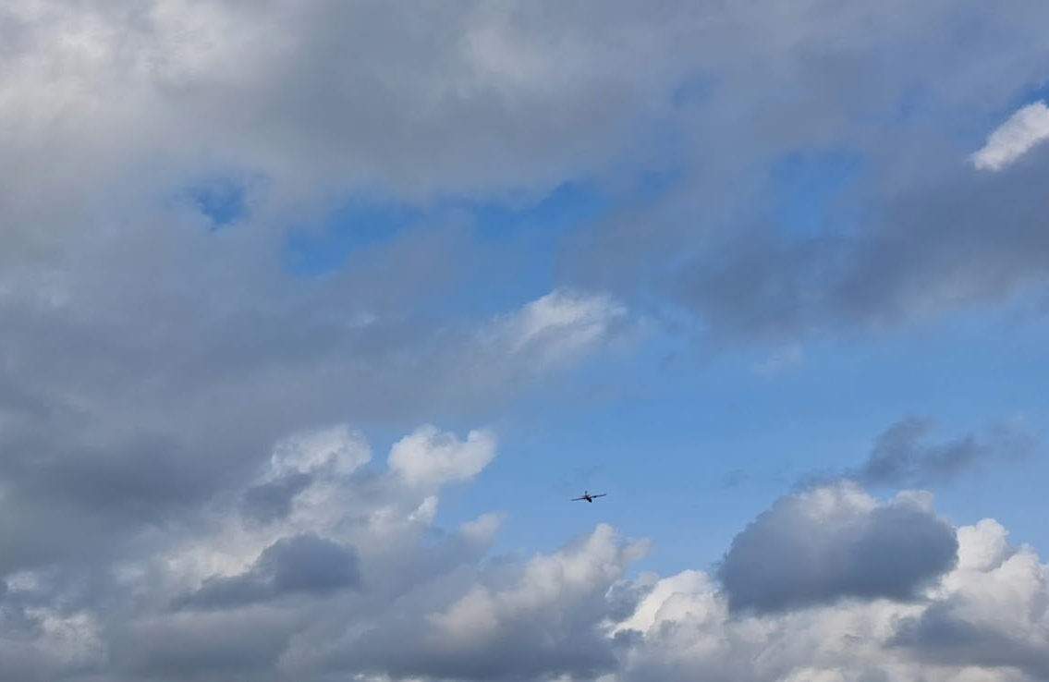
Figure 12.10: Horizontal flight - aircraft in cruise after transition.

Following vertical lift-off, the propellers were tilted forward from the vertical VTOL position to generate forward thrust. As airspeed built, the fixed-wing airframe transferred to wing-borne lift and sustained level cruise flight, confirming a successful VTOL-to-forward-flight transition.

Horizontal Flight Test 1
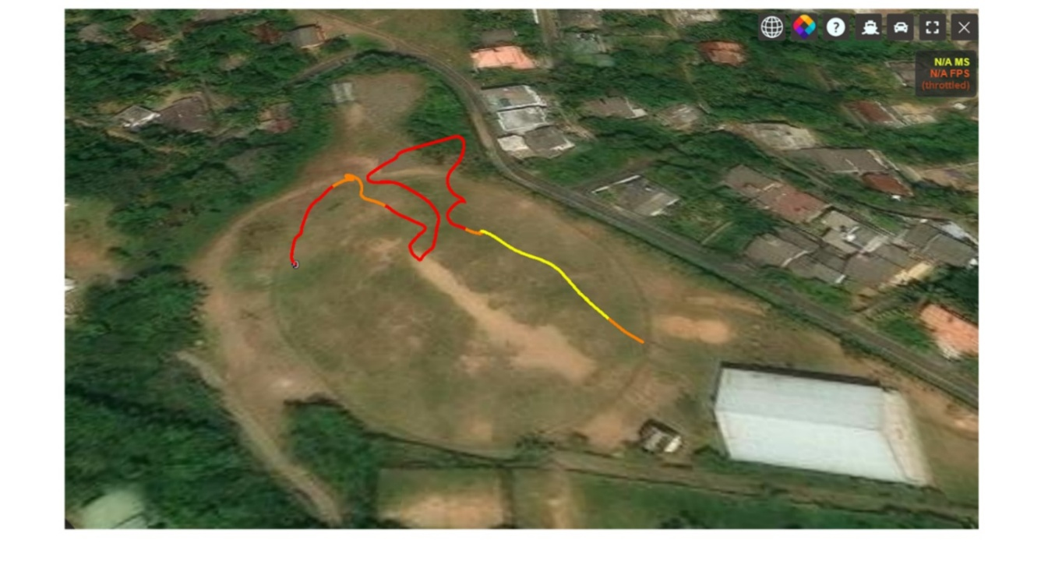
Figure 12.11: Horizontal Flight Test 1 - recorded position track.

The Test 1 ground track shows a looping, irregular path with several tight turns, suggesting the aircraft had difficulty holding a steady heading and course during and after transition.
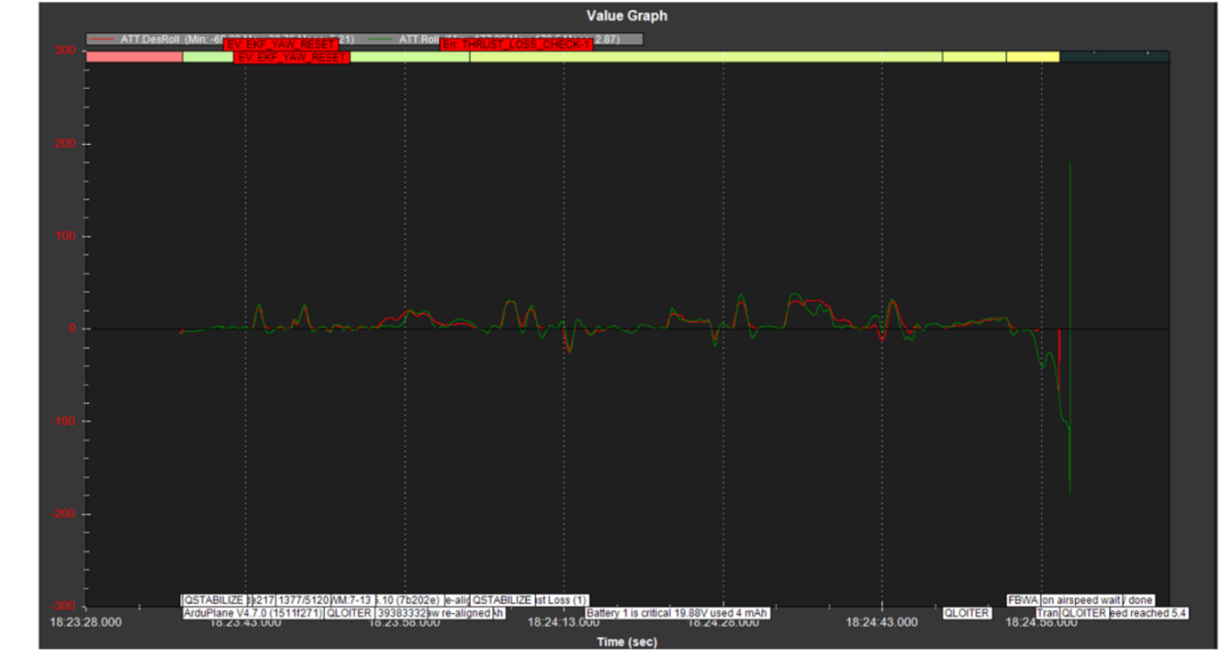
Figure 12.12: Horizontal Flight Test 1 - Desired Roll vs. actual Roll.
Observation:
- Large roll deviations observed
- Actual roll deviated from desired roll
- Significant lateral attitude disturbance
- Indicates loss of roll stability
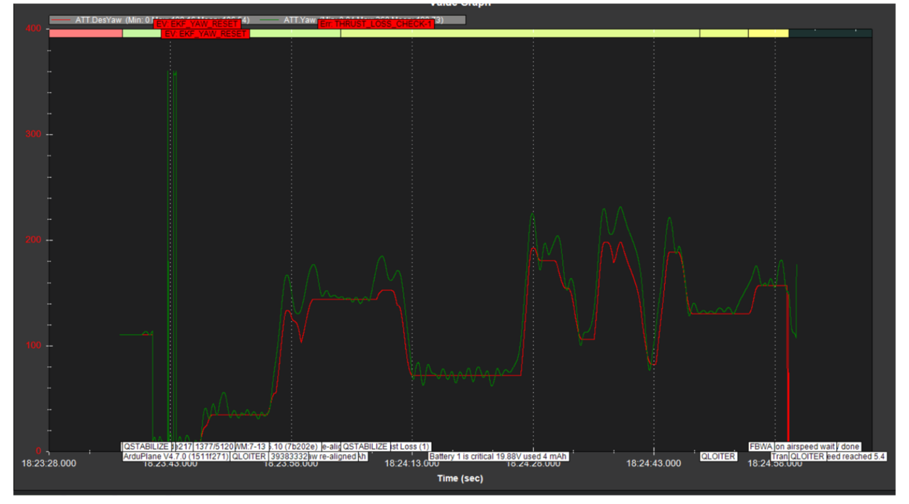
Figure 12.13: Horizontal Flight Test 1 - Desired Yaw vs. actual Yaw.
Observation:
- Significant yaw deviations
- Heading disturbance during transition
- Asymmetric thrust/moment affected yaw response
- Control stability was lost
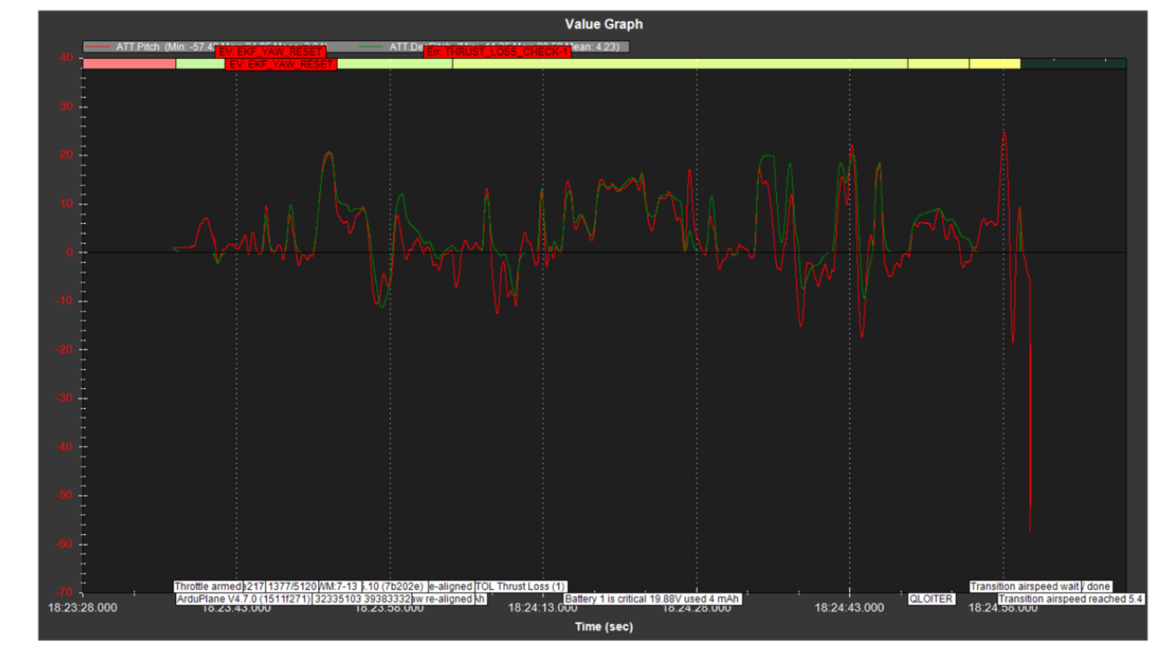
Figure 12.14: Horizontal Flight Test 1 - Desired Pitch vs. actual Pitch.
Observation:
- Significant pitch variations
- Poor pitch tracking
- Attitude disturbance during transition
- Contributed to loss of stability

Horizontal Flight Test 2

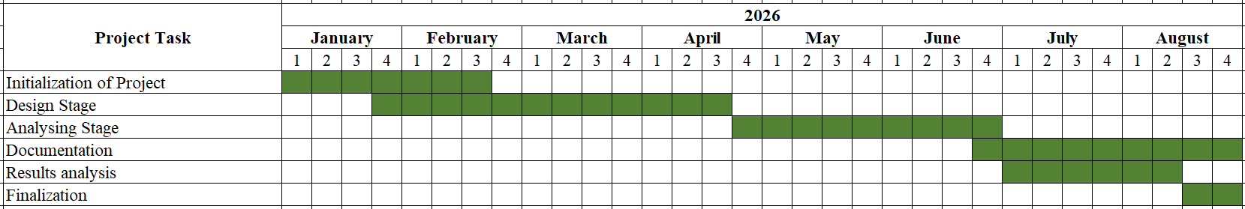
TIME PLAN
Table 13-1: Time Plan
Table 13-2: Descriptive Time Plan
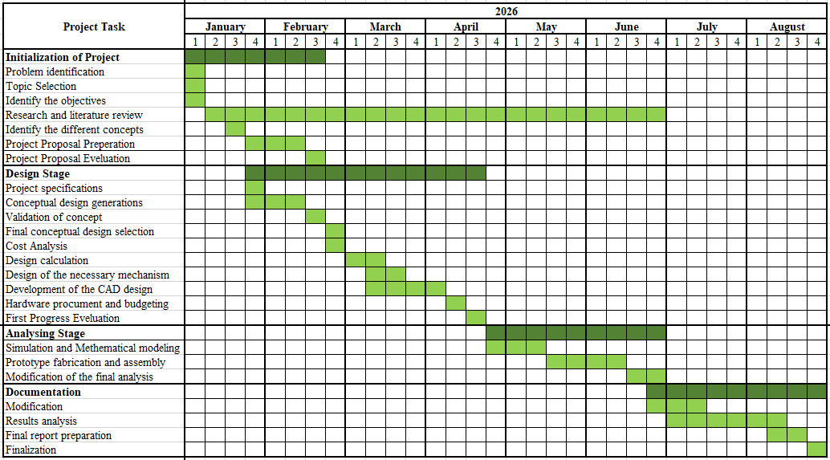

GROUP MEMBERS CONTRIBUTION

Table 14-1: Group Members Contribution
No | Name | Registration No | Contribution
1 | Hewaarachchi N.K. | EG/2021/4554 | Literature Review, Time Plan  Conceptual Design  Solidwors Modelling: Aircraft, Esc and controller mount, Stand, Arm Design  Simulation  Matlab State Space Model  Air Frame Assemblying
2 | Lakmini S.M. | EG/2021/4639 | Introduction  Methodology  Solidworks Modelling: Aircraft  Simulation  Air Frame Assemblying  Calculations
3 | Perera S. R. | EG/2021/4717 | Aim, Objectives  Resource Allocation and Budgeting  Ardupilot section of report  Solidwork Modelling: Tail Part, Tilting mechanism  Wiring of uav  Mission Planner  Flight Testing

REFERENCES
- J. Su, H. Huang, H. Zhang, Y. Wang, and F.-Y. Wang, “eVTOL performance analysis: A review from control perspectives,” IEEE Trans. Intell. Veh., vol. 9, no. 5, pp. 4877–4889, May 2024, doi: 10.1109/TIV.2024.3387405.
- C. Anderson, “Bell V-22 Osprey: The world’s most advanced military tiltrotor,” Defense Feeds, Jul. 11, 2025. [Online]. Available: https://defensefeeds.com/military- tech/air-force/transport-aircraft/v-22-osprey/ [Accessed: Feb. 08, 2026].
- M. Radotich, “Conceptual design of tiltrotor aircraft for urban air mobility,” Jan. 2022. [Online].Available:
https://rotorcraft.arc.nasa.gov/Publications/files/Michael_Radotich_13-Jan-22_03-47- 02.pdf [Accessed: Feb. 10, 2026].
- D. Mascio, D. Serrone, and L. Moretti, “Vertiports: The infrastructure backbone of advanced air mobility—A review,” Eng, vol. 6, no. 5, p. 93, May 2025, doi: 10.3390/eng6050093.
- “eVTOL aircraft | SKYbrary Aviation Safety,” Skybrary.aero, 2025. [Online]. Available: https://skybrary.aero/articles/evtol-aircraft [Accessed: Feb. 12, 2026].
- NASA, “UAM reference vehicles – SACD,” Sep. 30, 2023. [Online]. Available: https://sacd.larc.nasa.gov/uam-refs/ [Accessed: Feb. 11, 2026].
- A.Bacchini and E. Cestino, “Electric VTOL configurations comparison,” Aerospace, vol. 6, no. 3, p. 26, Feb. 2019, doi: 10.3390/aerospace6030026.
- R. Y. Yanev and I. Staack, “Framework development for conceptual design and configuration analysis of eVTOL aircraft,” in Proc. 34th Int. Council Aeronaut. Sci. (ICAS), 2024. [Online]. Available: https://www.icas.org/icas_archive/icas2024/data/papers/icas2024_0557_paper.pdf [Accessed: Feb. 11, 2026].
- C. Moreira and C. Breitsamter, “Aerodynamic interaction effects of tiltrotor eVTOL aircraft,” 2024. [Online]. Available: (Add official URL here) [Accessed: Feb. 11, 2026].
- W. Li, R. Cheng, H. Huang, A. Garg, and L. Gao, “Energy consumption modeling and optimization of an eVTOL aircraft: Integrating weight, motor, and battery dynamics,” Energy, Jun. 2025. [Online]. Available: https://doi.org/10.1016/j.energy.2025.136229 [Accessed: Feb. 13, 2026].
- M. Yang, Z. Wan, D. Yan, J. Chen, and R. Dong, “Initial weight modeling and parameter optimization for collectible rotor hybrid aircraft in conceptual design stage,”
Drones, vol. 9, no. 10, p. 690, Oct. 2025, doi: 10.3390/drones9100690.
- D. Han and G. Barakos, “Comparison of design features of quadrotor aircraft and helicopters from the point of view of flight performance,” Univ. Glasgow. [Online]. Available: https://eprints.gla.ac.uk/251107/1/251107.pdf [Accessed: Apr. 10, 2025].
- D. A. Ta, I. Fantoni, and R. Lozano, “Modeling and control of a tilt tri-rotor airplane,” HAL Open Science, Dec. 2012. [Online]. (Replace with official HAL publication URL) [Accessed: Feb. 10, 2026].
- M. Liu, Z. Su, J. Zhu, F. Guo, and Y. You, “Flight analysis and optimization design of vectored thrust eVTOL based on cooperative flight/propulsion control,” Aerosp. Sci. Technol., vol. 149, p. 109143, Jun. 2024, doi: 10.1016/j.ast.2024.109143.
- E. Enenakpogbe, J. F. Whidborne, and L. Lu, “Full envelope control of over-actuated fixed-wing vectored thrust eVTOL,” Aerospace, vol. 11, no. 12, p. 979, Nov. 2024, doi: 10.3390/aerospace11120979.
- G. Looye, A. Varga, and S. Bennani, “Robustness analysis applied to autopilot design part 1: μ-analysis of design entries to a robust flight control benchmark,” May 1998. (Add official publication details) [Accessed: Feb. 12, 2026].
- J. G. Leishman, “Electrically-powered aircraft,” in Introduction to Aerospace Flight Vehicles, Embry-Riddle Aeronautical Univ., vol. 59, Jan. 2023. [Online]. Available: https://eaglepubs.erau.edu/introductiontoaerospaceflightvehicles/chapter/electric-
aircraft/ [Accessed: Feb. 12, 2026].
- J. T. Hinke, L. M. Giuseffi, V. R. Hermanson, S. M. Woodman, and D. J. Krause, “Evaluating thermal and color sensors for automating detection of penguins and pinnipeds in images collected with an unoccupied aerial system,” Drones, vol. 6, no. 9,
p. 255, Sep. 2022, doi: 10.3390/drones6090255.
- NASA Office of Inspector General, “Management of the low-boom flight demonstrator project,” NASA, May 2020. [Online]. Available: https://oig.nasa.gov/wp- content/uploads/2024/02/ig-20-015.pdf [Accessed: Feb. 07, 2026].
- Q. Zhao, Y. Zhang, R. Wang, and Z. Zhou, “Modeling and control of distributed- propulsion eVTOL UAV hovering flight,” Vehicles, vol. 7, no. 4, p. 138, Nov. 2025, doi: 10.3390/vehicles7040138.
- Titan Dynamics, “TITAN Falcon V2 user manual,” Feb. 25, 2024. [Online]. Available: https://www.manualslib.com/manual/3357193/Titan-Dynamics-Falcon- V2.html [Accessed: Feb. 11, 2026].
- R. Piccinini, M. Tugnoli, and A. Zanotti, “Numerical investigation of the rotor-rotor
aerodynamic interaction for eVTOL aircraft configurations,” Energies, vol. 13, no. 22,
p. 5995, Nov. 2020, doi: 10.3390/en13225995.
- “Types and architectures of eVTOL aircraft,” Embention, Jan. 16, 2026. [Online]. Available: https://www.embention.com/embention-uam-academy/lesson/types-and- architectures-of-evtol-aircraft/ [Accessed: Feb. 11, 2026].
- A. Mohammed, “Commercial aircraft composite structure,” ResearchGate, 2026. [Online]. Available: https://www.researchgate.net/profile/Abubakar-Mohammed- 9/publication/337330958/figure/fig6/AS:826579521376269@1574083323771/Comme rcial-aircraft-composite-structure-Courtesy-of-Composites-Horizon-Inc.jpg [Accessed: Feb. 12, 2026].
- R. Patole, N. Ambhore, and D. Agrawal, “Carbon composites in aerospace application – A comprehensive review,” Mater. Int., vol. 5, no. 4, 2023, doi: 10.33263/Materials54.002.
- “Commercial aircraft composite structure,” Jun. 2026. [Online]. Available: <original source URL> [Accessed: Feb. 16, 2026].
- Federal Aviation Administration, “Federal Aviation Administration,” 2023. [Online]. Available: https://www.faa.gov/ [Accessed: Feb. 12, 2026].

